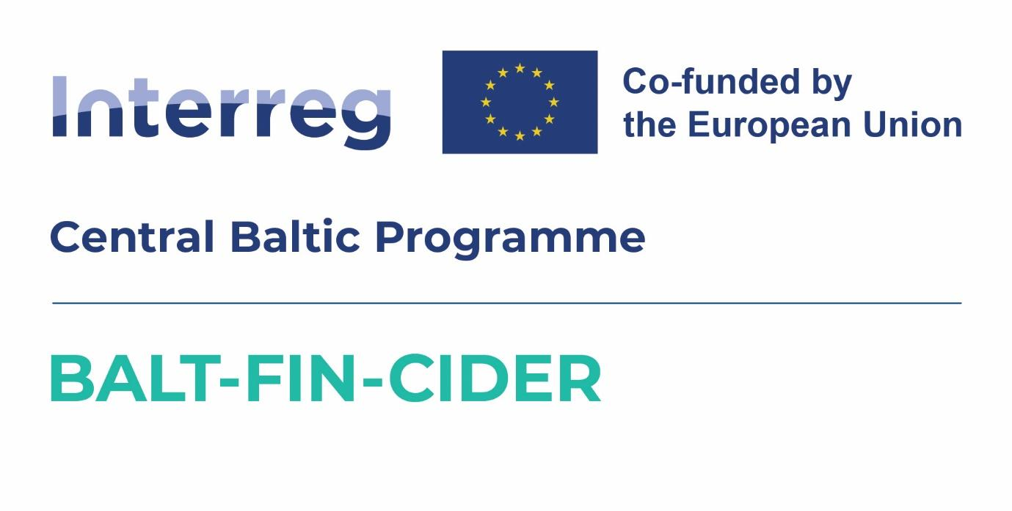

|  |  |
| --- | --- |
| **Project:** | **Exports of the Baltic and Finnish Craft Ciders to Australia** |
| **Project ID and**  **acronym:** | CB0700297– BALT-FIN-CIDER |
| **Project Partners:** | Latvian Country Tourism Association "Lauku celotajs" (Lead Partner)  NGO Estonian Rural Tourism |

**2nd PROJECT PARTNER MEETING AGENDA**

8th of September 2025,

**Hestia Hotel Strand,**

Pärnu, Estonia

**Monday, September 8, 2025**

|  |  |
| --- | --- |
| 9:40 - 10:00 | Registration and welcome coffee |
| 10:00-11:00 | **FACE-TO-FACE MEETING (WITH PROJECT PARTNERS AND SMEs PARTICIPATING)**   * Opening, updates and news from Project Partner**s** * **Representing Baltic cider at sales and marketing events**, such as ProWine in Singapore and Düsseldorf, CiderCon, The 60th Australian Latvian Arts Festival (in Adelaide, 26th - 31st December, 2025) etc. |
| 11:00-12:30 | **Gabe Cook technical webinar together with Sigrid Gertsen Schibbye (Lallemand)**  Cider Making Run through (presented by Gabe Cook)   * Apple selection * Milling/pressing   Yeast & Nutrition (presented by Sigrid Gertsen Schibbye)   * Critical role in cider making process * Selection of different yeasts for different needs and purposes * Importance of inoculation * The role of balanced nutrition * Controlling microbiology - pH, So2 and associated products |
| 12:30-13:30 | Lunch |
| 13:30-14:00 | **Project partner meeting**, discussions |
| 14.00-15.30 | **Gabe Cook Commercial Webinar together with Tom Oliver (Oliver's Cider & Perry)**   All the considerations that need to be made in order to establish a viable enterprise   1. Know your drinker 2. Sensory profile 3. Pack type 4. Brand identity 5. Route to market |
| 15:30-16:00 | Coffee break |
| 16:00-18:00 | Steering group meeting. Providing information about State support for export activities.  Discussions on Baltic cider participation in international fairs/events. Rules and possibilities;  Developing first BalticCider Newsletter, content, distribution. |
| 19:00 | Dinner |