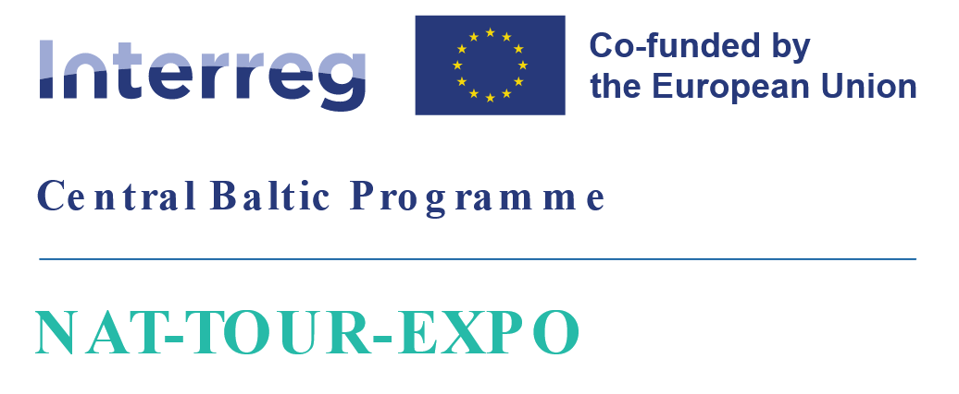

|  |  |
| --- | --- |
| **Project:** | **Exporting Baltic Nature Tourism to UK** |
| **Project ID and acronym:** | CB0100030 – NAT-TOUR-EXPO |
| **Project Partners:** | * Latvian Country Tourism Association "Lauku celotajs" (Lead Partner) * NGO Estonian Rural Tourism * Estonian Nature Tourism Association * Latvian Nature Tourism Association |

**PROJECT PARTNER MEETING**

**AGENDA**

4th of September 2024, Rīga, Latvia

Lauku Ceļotājs office, Kalnciema iela 40

|  |  |
| --- | --- |
| 10:00 – 12:00 | **Morning coffee**  PROJECT PARTNERS MEETING Part 1  Introduction of agenda, reporting progress,   * SMEs tables for CB reporting: 1. sales  <https://docs.google.com/spreadsheets/d/1R8m88ETCa-YmuadkBbahJcGVxE73ZsUA/edit?usp=sharing&ouid=102598555421590841678&rtpof=true&sd=true>;   2. trainings and events  <https://docs.google.com/spreadsheets/d/11PVzozbmj4JbSnLHWOV87S723RoZzLuz/edit?usp=sharing&ouid=102598555421590841678&rtpof=true&sd=true>  *LV Anna Salnikova, EE – Elin Priks*   * Statistics on sales for the year 2024 from SMEs, feedback on survey 2023 – Anna S. * Progress and news from CB, *Asnate Ziemele (LC)* * Web portal info and updates, statistics https://balticnaturetourism.com, *Anna Saļņikova, Toms Ziemelis* * Overview on registration of nature tourism SMEs and their offered products, progress of product examples. *Anna Saļņikova (LC) and Elin Priks (ERTO)*, *LNTA, ENTA* * Upcoming sales events 2024 / 2025 – *Asnate Ziemele and Raili Mengel* |
| 12:30 - 13:30 | **Lunch** in the nearby local/cafe "Veldze" <https://www.facebook.com/LokalsVeldze/> |
| 13:30 - 17:00  (with coffee break) | PROJECT PARTNERS MEETING Part 2   * Training events for SMEs in EE and LV, A summary of challenges and mistakes found in on-site visits and customer feedback.   *LNTA (1), ENTA, LC (2), ERTO*   * Video schedule plan confirmation for the last reel and long (3min) promo video, Toms Ziemelis (LC) and *Anna Salnikova (LC)* * Feedback on the study trip – common discussion * Product brochure? (in AF: 3 annual editions. On-line and print versions in English. Ca 6000 copies a year.) * Set of promo materials   Activity 1.7, National dissemination events  Activity 1.9, Project communication to SME target audience  **Cofee break**  **WP2 Product marketing and sales for UK**  Activity 2.1, Estonian-Latvian nature tourism product presentation at specialised travel trade events  Activity 2.2, FAM trips for UK tour operators, travel companies and media  Activity 2.3, Estonian-Latvian nature tourism product presentation at travel markets  Activity 2.4, Estonian-Latvian nature tourism product presentation to nature organisations in the UK  Activity 2.5, Sales calls to specialised companies in UK  Activity 2.6, Digital marketing, Result statistics after advertisement activities for particular project period – *Anna P. + ERTO*  Activity 2.7, E-newsletters – *Anna P/Anna S. + ERTO*  Activity 2.8, Review of other sales and marketing platforms – *Anna S.*  Activity 2.9, Project communication to general public – Social networks, PR in LV/EE  **At 16.00 Info from UK market experts - Paul Wagner and Andrew Fairburn will join on-line.**   * Next Project meeting + experience on products on site. |
| 17:00 | End of meeting |

Info on project and meeting: Toms Ziemelis +371 2865 1372