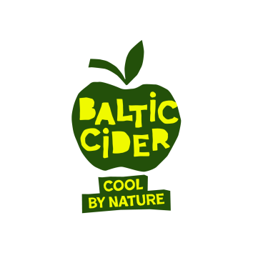
Meet and Taste Baltic Cider on Tour in Batlow, Sydney and Melbourne This May
The Baltic Cider collective is heading to Australia this May, bringing a lineup of cool-climate ciders that most Australians have never had a chance to try. The team will be pouring and presenting their ciders at across three stops:

- Batlow Cider Fest, 15–16 May
- Sydney cider and brewery events, 18–19 May
- Pint of Origin Festival, Beermash, Melbourne, 21–24 May

Meet Baltic Cider
“Up Over” meets “Down Under” as Baltic cider makers arrive from Northern Europe to celebrate cider together with Australian audiences.
“Baltic” represents three countries on the Baltic Sea: Latvia, Estonia and Finland - united by a shared approach to real cider-making. Made from whole apple juice and shaped by a cool northern climate, these ciders are known for their crisp, fresh character and real apple flavour. Cool by nature and distinctly different, Baltic ciders offer a tasting experience well worth discovering.
Tour Schedule
15 May – Trade and Media Event, in the Tumut River Brewing Co in cooperation with The Apple Thief cidery.
16 May – Batlow Cider Fest
- Tastings, sales and producer discussions. 11:30 Tasting and Q&A Sessions in The Can at Hides Park.
18–19 May – Sydney Events
- The Sydney Cidery and brewery activations
21–24 May – Pint of Origin Festival, Beermash in Melbourne
- Baltic Cider featured throughout the festival

22-23 May – Industry and Trade Presentation in Melbourne
- Hosted with Beermash
- Followed by a public tap takeover

Availability
Baltic ciders are available in Australia with short delivery times. The range includes a variety of styles, from sweet through to dry, as well as ciders with natural fruit and botanical additions, offering plenty to explore.

For stockists and online orders, visit: https://balticcider.houseofdrinks.com.au

Contacts:
Asnate Ziemele
Baltic Cider Team
+371 29285756
asnate@celotajs.lv or info@balticcider.com

Website: https://balticcider.com/en
Instagram: https://www.instagram.com/baltic_cider
Facebook: https://www.facebook.com/balticcider
LinkedIn: https://www.linkedin.com/company/baltic-cider

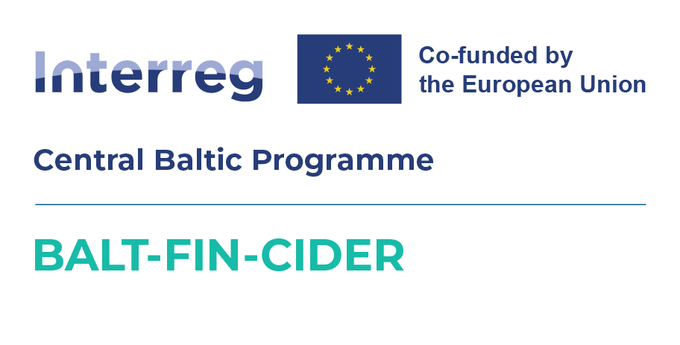

Promotional tour and programme is supported by Interreg Central Baltic Programme 2021-2027 project CB0700297 – BALT-FIN-CIDER (Exports of the Baltic and Finnish Craft Ciders to Australia)

