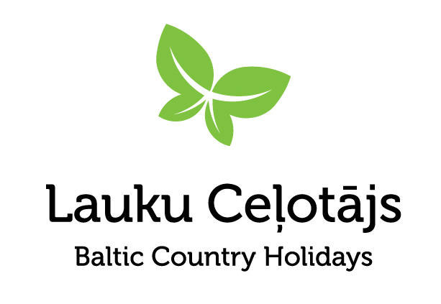

Press release

Latvian Artisan Cheeses and Ciders — Pairing Flavours and Unlocking the Potential of Gastronomic Tourism
On 15 October, the Latvian Country Tourism Association brought together hospitality and tourism professionals and the media at restaurant Kaļķu vārti in Riga for a showcase of Latvian artisan cheeses and ciders. Guests sampled cheeses and ciders paired in a variety of snacks and dishes, discovering the possibilities offered by high-quality products from local producers and exploring new opportunities for collaboration to bring them into Latvia’s gastronomic and tourism offer.

Artisan Cheeses and Ciders
Latvian artisan cheeses and ciders are made from local ingredients: cheeses from high-quality milk produced by Latvian cattle, sheep and goats, and ciders from apples grown in local orchards. Their quality is the result of careful craftsmanship and each producer’s individual approach, in contrast to industrial production. These local products showcase the skill of their makers while strengthening the local economy.
The cheese producers presenting their products at the event were Lapsu Mājas siers, Gredzenmuiža, SIA Siera ražotne, Nīcas siers, SOIRA, Birznieki Farm, Piena Aitas Bio, Rehtšprehera siers and Kazdangas siers / Baltu piens.
The cider-making community was represented by Mūrbūdu Cider Brewery, Abuls Cider Brewery, Sabiles Sidrs, Turkalnes muiža, Lauskis Winery, Mr. Plūme Cider Brewery and Pienjāņi Cider Brewery.
Travellers can already set out to discover Latvia’s local flavours. Both cheese makers and cider producers welcome visitors, offering tours of their production facilities, tastings and a wide range of products to take home. Further information is available on the culinary tourism route websites Cheese Route and Cider Route.

Collaboration Creates Added Value
Gastronomy is an important part of the travel experience, offering a way to discover a country through its local flavours, stories and traditions. Local products have untapped potential to help establish Latvia as a sought-after destination for food-loving travellers. To bring these products to a wider audience, it is essential to create opportunities for producers, chefs, restaurants and tourism professionals to meet and work together.

The Art of Creating Flavour Experiences
For the tasting, Kaļķu vārti chefs Inga Cīrule and Edgars Piskunovs created special snacks and dishes that showcased Latvian artisan cheeses and ciders in new, carefully considered flavour combinations. As head chef Edgars Piskunovs observed: “Cheese and cider work wonderfully together, and once you have tasted these combinations, their compatibility seems entirely natural.”

Participants and Feedback
A total of 60+ people attended the presentation and tasting, including representatives of hotels and restaurants, tourism businesses, the media and organisations from related sectors. Feedback from participants demonstrated interest in this approach:
- “Bravo! An excellent event that became something truly special — and could, in turn, develop into a fantastic gastronomic tourism product.”
- “An excellent, almost exclusive and inspiring event. Perhaps something similar could be organised as part of Home Café Days.”
The event demonstrated that promoting local products through gastronomic experiences is a practical way to strengthen cooperation across sectors, raise the profile of producers and create an appealing showcase of Latvian flavours for visitors.

Project No. 25-00-C0LA2002-000001 “Culinary tourism route “Cheese Road” for the promotion and recognition of local cheese producers” is being implemented with the financial support of the EAFRD. Supported by the Ministry of Agriculture and the Rural Support Service.
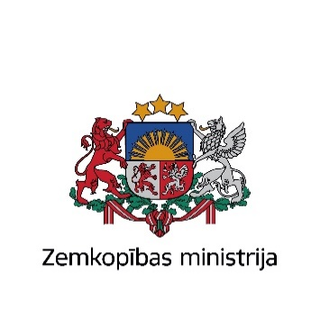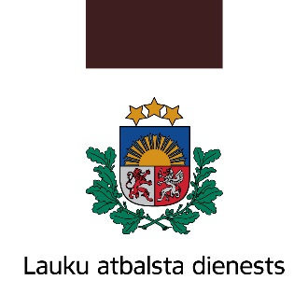
Project “Knowledge-driven Baltic Cider Production and Branding for Growth and Competitiveness of SMEs” (EE-LV00145) is being implemented with the financial support of the European Union under the Interreg VI-A Estonia-Latvia Programme 2021-2027.


