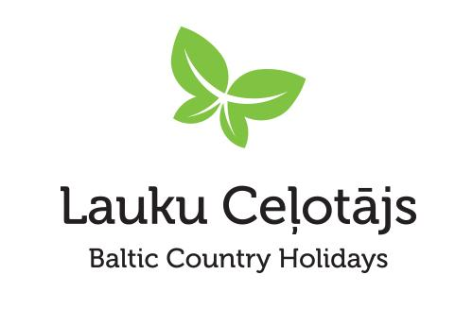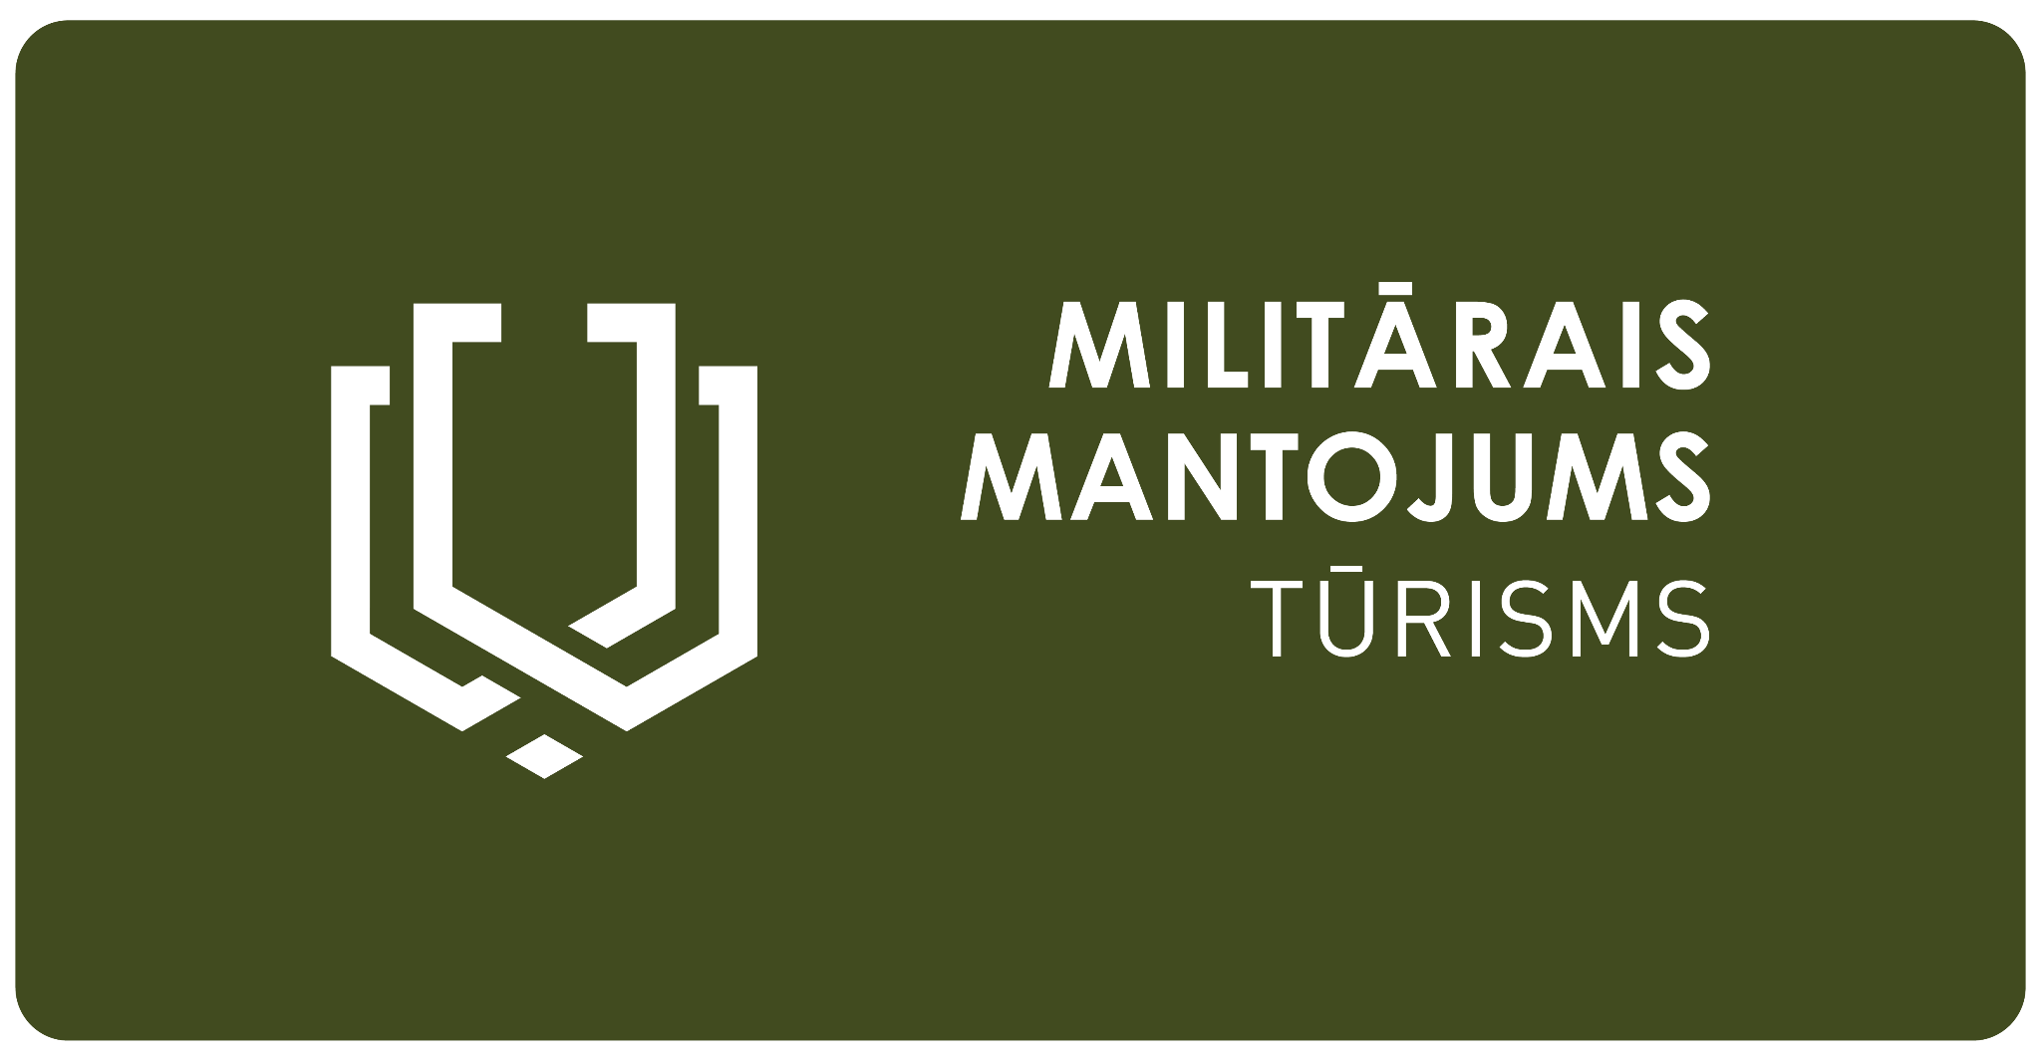

Press release 28.05.2025

**Strong Yesterday, Free Today: Exploring a Century of Baltic Independence Through Military Heritage Tourism**

*On the border between East and West in Europe, the Baltic countries — Latvia, Lithuania, and Estonia — have stood for their independence over the past 100 years. Military heritage tourism uncovers this story, highlighting the Baltic role in European geopolitical processes from the end of World War I to the present day.*

**The Shared Baltic Story of Independence**

From the time Latvia, Lithuania, and Estonia became independent in 1918 to the moment all three Baltic States restored their independence in 1990-1991, many traces have remained — battle sites, military structures, historical photographs, and personal memories. Together, they form a shared military heritage narrative: what happened during World War I in the Baltic territories, how, at the end of the First World War, Latvia and Estonia gained independence while Lithuania regained its statehood; how the countries defended their existence in the Wars of Independence; how they flourished between the two World Wars; how all three were devastated by the Second World War; why, for more than a decade after the war, national partisans resisted Soviet occupation; and how, after decades of oppression, independence was finally restored.

**Discover Baltic Military Heritage Tourism: All on One Website**

The website [militaryheritagetourism.info/en](https://militaryheritagetourism.info/en) lists more than 943 military heritage sites, including museums, fortifications, military equipment, trails, bunkers, battlegrounds, military towns, infrastructure and memorial sites.

The sites are arranged along a timeline so as to focus on the most important historical events, individuals and stories. The timeline emphasises 270 events, and the website presents 139 topics which relate to the history of military heritage. There is a broader description of each location, and contact information is provided. Touring route suggestions are also included, offering visitors ideas for exploring key historical sites. The website also includes more than 330 stories submitted by history enthusiasts.

Information about military heritage tourism in the Baltics can also be found on Facebook and Instagram @militaryheritagetourism, as well as in Military Heritage Tourism guides and maps <https://militaryheritagetourism.info/en/info/publications>.

**Upcoming Media Tour: Visiting Military Heritage Sites in Latvia and Lithuania**A media tour will take place at the end of this summer, featuring visits to 19 remarkable military heritage sites in Latvia and Lithuania. Highlights include the Cold War Exposition at the Plokštinė Ballistic Missile Complex, located in a former Soviet ballistic missile launch facility; the Karosta Prison, the only former military prison in Europe open to the public; and the exhibition "History of KGB Operations in Latvia," housed in the former KGB building.

The five-day tour will provide a comprehensive and engaging experience. The itinerary is divided into two consecutive parts, giving participants the flexibility to join either Part 1, Part 2, or the full tour — depending on their availability and interest. The full tour programme is available here: [www.celotajs.lv/g/www/news/2025/Media_tour_program_Military_Heritage_Lat-Lit.pdf](https://www.celotajs.lv/g/www/news/2025/Media_tour_program_Military_Heritage_Lat-Lit.pdf).

More information about registration will follow.

Asnāte Ziemele  
Chair of the Board  
Latvian Country Tourism Association  
[asnate@celotajs.lv](mailto:asnate@celotajs.lv)   
+371-2928-5756

*Project LL-00052 “Extending the Baltic military heritage tourism product in Lithuania and South Latvia" (Military Heritage II) is being implemented with the support of the European Union Interreg VI-A Latvia–Lithuania Programme 2021- 2027.*

*This press release has been produced with the financial support of the European Union. Its contents are the sole responsibility of the Latvian Country Tourism Association "Lauku ceļotājs" and do not necessarily reflect the views of the European Union.*

