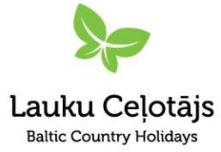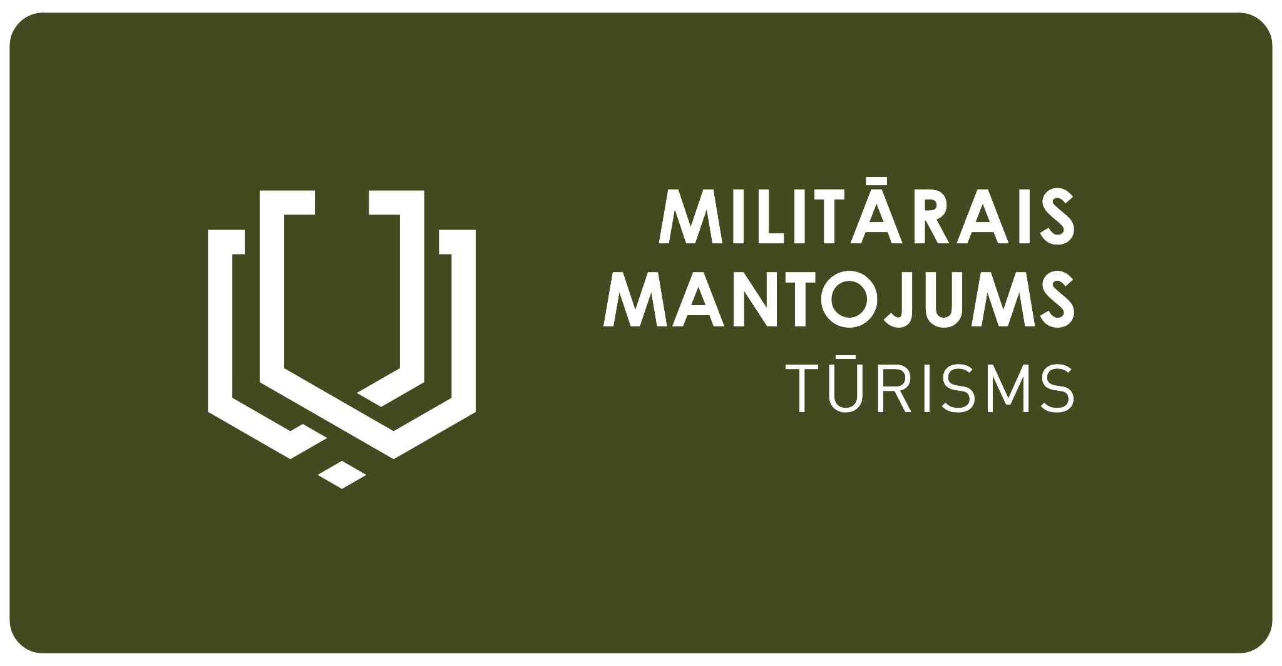

### 

### **Press Release** 08.01.2025

**Representatives from the Baltics, Europe, and the Nordic Countries Meet in Latvia to Discuss the Role and Opportunities of Military Heritage Tourism in History Education**

*Building bridges of collaboration between history, education, and tourism, an international conference, “Integrating Military Heritage into Tourism and School Curricula”, will take place in Riga on 10 January. This will be followed on 11 January by the commemorative event of the Christmas Battles in Latvia, featuring a battle reenactment, which serves as an example of engaging historical storytelling through active experiences. The conference has attracted over 120 participants from across the Baltics, including owners of military heritage sites and objects, museums, history teachers, school representatives, researchers, and tourism professionals from Latvia, Estonia, and Lithuania.*

Across the Baltics, Europe, and the Nordic countries, the key challenge remains how to present history in an engaging way without losing the attention of the audience, particularly school-aged youth. Military heritage tourism offers a way to support history education by linking interest with an authentic representation of historical facts. International collaboration and exchange of experiences at the Baltic, European, and Nordic levels provide an opportunity to enrich history curricula with a broader perspective beyond national borders.

### **The Conference**

The conference *“Integrating Military Heritage into Tourism and School Curricula”* will take place on 10 January at the Latvian War Museum in Riga. It is organised as a platform for exchanging experiences and discussing how to present history through military heritage tourism.

#### **Key Themes of the Conference:**

* **The Story of Baltic Independence**The conference will begin with an exploration of the shared experiences of Latvia, Estonia, and Lithuania in developing military heritage tourism, focusing on the story of Baltic independence from World War I to the present day.  
  A military heritage tourism portal, <https://militaryheritagetourism.info/en>, created through collaborative projects with history experts, now includes 845 former military sites. Many of these have visitor programmes offering experiential storytelling. The database also features 300 personal memory stories, 264 historical event descriptions spanning seven time periods, 126 detailed historical topics, and 26 travel routes in the Baltic States.  
  The development of military heritage tourism will be presented by Asnāte Ziemele, President of LLTA “Lauku ceļotājs.”
* **Transforming Military Sites and Sharing Their Stories with Diverse Audiences.**

How can one ensure a credible personal story that is also historically balanced and relevant to an audience with no personal memories of the period? *Thomas Tram Pedersen, Historian, founder of the Cold War Museum at Stevnsfort, Denmark.*

* **Times They Are A-Changin'. Learning from the Cold War.**

Education, visits of school classes, and re-enactments of the Cold War in the Netherlands. *Ben de Vries, Historian and Programme Manager of Military Heritage at the Dutch Cultural Heritage Agency, Ministry of Culture, the Netherlands.*

* **Cold War in the School Curriculum in the UK.**

The practices around education and audience engagement through annual events and educational offerings aligned with the school curriculum to promote the Cold War heritage awareness and visitor engagement. *Milka Blagoeva Ivanova, The Cold War Network.*

* **The Winter War Museum at the Battlefield Site: Sustaining Visitor Interest.**

Europe’s largest Winter War Museum focuses on sensory experiences and a human approach to the history of the war, sharing with visitors the lives of soldiers and civilians during wartime. *Reima Haapoja, Minna Torkkola, Winter War Museum Raatteen Portti, Finland.*

* **Remembrance Tourism in Flanders Fields: a Meaningful Experience for Young People.**

Remembrance Tourism is a key focus at Visit Flanders, with Flanders Fields attracting international visitors to its battlefields and war memorials. *Veerle Viaene, the heritage coordinator at Visit Flanders, Belgium.*

* **Discussions**A significant part of the conference will be dedicated to participant questions and discussions following the presentations. Historian Valdis Kuzmins from the Latvian National Defence Academy will moderate the discussions.

### **Christmas Battles Commemoration Event on 11 January**

As a practical example of the conference topics, the Christmas Battles Commemoration Event will take place on 11 January, offering an emotionally engaging and participatory historical experience.  
The event will begin with a reenactment of the Christmas Battles at 14:00 near Antiņciems Cemetery, followed by a commemorative ceremony at Mangaļi homestead, the Latvian Youth Guard oath, and speeches. Military heritage tourism project partners from Latvia, Lithuania, and Estonia will have an information stand at the event, where visitors can also obtain the newly published Baltic States military heritage tourism map. The event will conclude with a torch-lit procession and remembrance gathering at Ložmetējkalns, with bonfires and songs.

### **Organisers**

The conference is organised by the Latvian Country Tourism Association in cooperation with the Estonian Rural Tourism Organisation (ERTO). The conference will be attended by partners of the Military Heritage project, who are using project support to invest in their military heritage tourism sites, making them more accessible and engaging for diverse audiences, including school youth. These include: Karosta NGO, Ltd. Rehabilitation Centre “Ligatne”, Saldus regional municipality, Municipal Agency “Cēsis Business and Tourism Agency”, Association of the Occupation Museum of Latvia. The conference is being organised with financial support from the Interreg Estonia-Latvia Cross-Border Cooperation Programme.

Before and after the conference, international guests will have the opportunity to visit several military heritage tourism sites in Riga and beyond. Special thanks for their support in organising the visit programme go to the Latvian Occupation Museum (Corner House, the KGB building), SIA Līgatne Rehabilitation Centre (Soviet Secret Bunker), and Cēsis Municipality Business and Tourism Agency (Cēsis Museum – Historical Exhibition “Fire of Conscience”).

The commemorative events of the Christmas Battles are organised by the Christmas Battles Museum (Latvian War Museum) in collaboration with Jelgava Municipality, the National Armed Forces, and representatives of the Military Heritage Tourism Project – Latvian Country Tourism Association, Zemgale Planning Region, the Latgale Tourism Association, the Lithuanian Rural Tourism Association, and the Žemaitija National Park Directorate (Lithuania). The project is implemented with financial support from the Interreg Latvia-Lithuania Cross-Border Cooperation Programme.

We continue to highlight the Baltic States’ shared story of independence through military heritage tourism with the motto:  
 **“Strong yesterday – free today!”**

Asnāte Ziemele  
Chair of the Board,  
Latvian Country Tourism Association  
T.: +371 29285756

About the Projects:

*The project LL-00052 “Extending the Baltic military heritage tourism product in Lithuania and South Latvia” (Military Heritage II) is being implemented with the support of the European Union Interreg VI-A Latvia-Lithuania Programme 2021-2027. This publication has been produced with the financial support of the European Union. Its contents are the sole responsibility of "Lauku ceļotājs" and do not necessarily reflect the views of the European Union.*

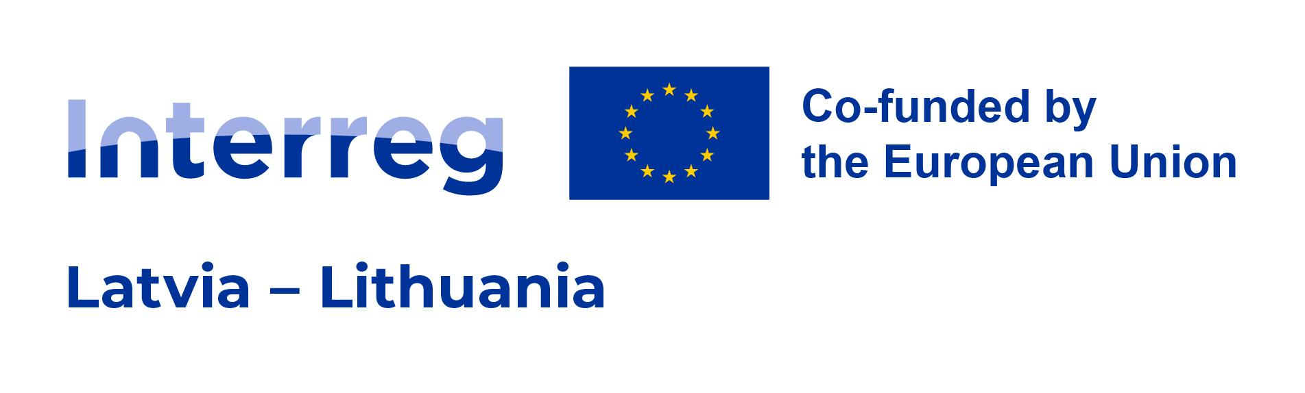

*The project EE-LV00094 “Improved Accessibility of the Latvian-Estonian Military Heritage Tourism Product" (MIL-HER ACCESSIBLE) is being implemented with the support of the European Union Interreg VI-A Estonia–Latvia Programme 2021-2027. This publication reflects the views of the author. The managing authority of the programme is not liable for how this information may be used.*

