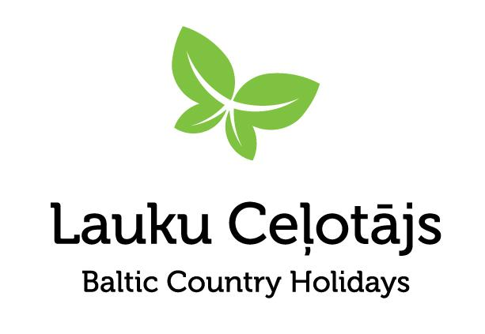

News release January 28, 2025

**Meet Baltic Cider at the CiderCon 2025 conference in Chicago, USA, on 4-7 February**

*Latvian craft ciders will be representing Baltic Cider at CiderCon 2025 in Chicago, USA—the premier annual cider conference for industry professionals. This event offers an excellent opportunity to learn, share experiences, taste ciders, and network with people from around the world working across various sectors of the cider industry.*

Baltic Cider represents authentic craft ciders made by family-run cideries in Latvia and Estonia. Blending tradition with innovation, they create unique, flavorful ciders from pure apple juice sourced from local orchards. Their distinctive taste is shaped by the cooler Northern European climate.

*Baltic Cider - Cool by Nature!* is an emerging brand that will be represented at CiderCon 2025 by the [Latvian Cider route](https://www.celotajs.lv/en/c/brand/ciderroute), a collective of Latvian craft cideries. These producers not only craft ciders that have earned accolades at international competitions but also welcome visitors to explore their craft. In collaboration with their Estonian peers, these cider makers are engaged in an exciting joint project with research institutes, analyzing apple varieties and the biochemical composition of apple juice to achieve the desired cider qualities and define the unique taste of Baltic Cider.

Some outstanding Baltic Cider samples will be poured for tasting at the Cider Share event, which kicks off the conference. This gathering of cider professionals celebrates their craft, sharing ciders and the stories behind their creation, fostering connections between old friends and building new relationships within the international cider community.

Ciders from Abuls Cidery and Mūrbūdu Sidrs will be proudly featured at the Cider Share event. Abuls is one of Latvia’s most experienced cideries, while Mūrbūdu Sidrs boldly experiments with innovative cider-making techniques.

### 

### **Ciders from** [**Abuls Cidery**](https://www.abuls.lv/)**:**

* **Yarlngton Mill/Antonovka** - sparkling 2023. medium sweet keeved cider. Made using 75% estate-grown bittersweet cider apples primarily of the Yarlington Mill variety and 25% acid apple varieties, mainly Antonovka, with some wild seedlings as well. The apples were harvested in October and November, the juice pressed and keeved in mid to late November. Keeving is a fermentation method that results in naturally sweet, sparkling cider without added sugar. Fermented with wild yeasts at a low temperature, the cider was bottled in August 2024.
* **Kerr 2022** - this is single variety cider made from the cold tolerant estate-grown Canadian origin aromatic crab apple variety Kerr. Known for producing highly aromatic ciders, Kerr trees are challenging to cultivate – they yield fruit late, only every other year, and grow slowly to a small size. The 2022 Kerr apples were harvested and pressed in late October, fermented to dryness using white wine yeast, and underwent secondary fermentation in the bottle using the traditional method. This cider is fully dry, aromatic, naturally sparkling, and has a wine-like character.

### 

### **Cider from Cider from** [**Mūrbūdu Sidrs**](https://www.facebook.com/murbudu/)**:**

### **Semi-Sweet Apple Cider with Aronia. Vintage 2019** This 2019 Aronia cider was aged for 18 months in American oak barrels previously used for Jim Beam bourbon. The cider offers the unique character of the 2019 vintage combined with the smoothness and depth that only time can provide. The addition of aronia berries is a distinctive flavor characteristic of Latvian ciders. Expect fresh American oak notes, a rich bouquet of red fruits, and a touch of oak sweetness, resulting in a full-bodied cider.

Baltic Cider will be represented at the conference by Baltic Country Holidays - the Latvian Country Tourism Association, promoting Baltic Cider as a delightful part of culinary tourism in the Baltic States.

See you at CiderCon2025!

Asnāte Ziemele

Chair of the Board  
Baltic Country Holidays

[asnate@celotajs.lv](mailto:asnate@celotajs.lv)  
+371 29285756

