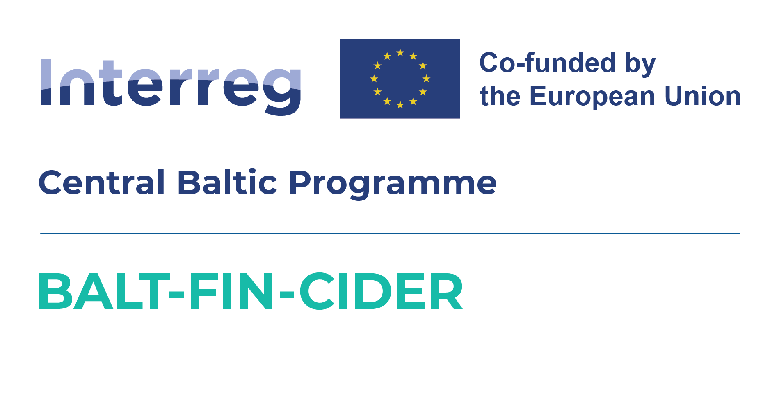

Press Release 06.11.2025

Authentic apple ciders from Latvia, Estonia and Finland join forces for their first export mission to the Australian market
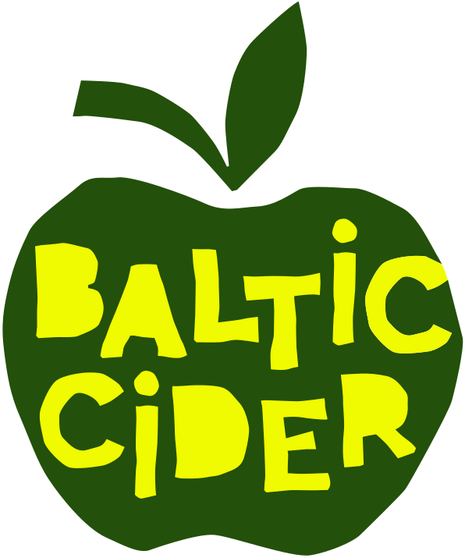
From 19 October to 1 November, the first Baltic Cider trade mission took place in Australia, promoting authentic apple cider from Latvia, Estonia and Finland. As part of the mission, cider makers from the three countries won medals at Australia’s largest cider competition – the Australian Cider Awards.

The export mission to Australia was carried out by a united Baltic Cider team as part of the Interreg Central Baltic project “Exports of the Baltic and Finnish Craft Ciders to Australia”, bringing together the Latvian Country Tourism Association “Lauku ceļotājs”, the Estonian Rural Tourism Organisation, and cider makers from all three countries – Latvia, Estonia and Finland.

The Australian Cider Awards competition – a launch platform for market entry
At the prestigious Australian Cider Awards competition, the following cider makers represented:
- Latvia: Mr. Plūme, Tālava, Mūrbūdu, Abuls, Sabiles Sidrs, Abavas, Pienjāņi, Herbsts, Turkalnes Muiža, and Lauskis;
- Estonia: Tori, Kodas and Jaanihanso;
- Finland: Lepola, Pirula, Hallonmäen, and Vaski Cider.
- The competition annually brings together not only the best cider producers but also beverage trade representatives – wholesalers, retailers, restaurants, and other potential distributors – providing participants with valuable market contacts and media visibility.
- Among 231 ciders entered in 44 categories, the Baltic ciders collectively won 27 medals: 1 gold, 10 silver, and 16 bronze.
- The gold medal in the category “Speciality Styles - Cider or Perry with Botanicals” was awarded to Mūrbūdu Cidery (Latvia) for their “Gin Botanical” cider – a semi-dry sparkling cider matured with traditional gin botanicals such as lemon peel, coriander seeds, orange peel, and juniper berries, characterised by a fresh green apple aroma and a balanced juniper-citrus taste.

- Category winners included Lepola Cider (Finland) with “Perry, Lepola” – in the category “New World Perry - Sweet”, and Kodas Cider (Estonia) with “Mimikri” – in the category “Traditional Cider - Sweet”.

Information about the silver and bronze medal winners is published on the Baltic Cider website at Baltic Cider News & Events.
These excellent ciders are also available to taste and purchase in Latvia, Estonia and Finland.

- Each year, the competition also selects the best cider packaging design for bottles and cans. This year’s winner was Abava Winery (Latvia) for its outstanding bottle and label design.

Baltic Cider masterclasses for cider distributors
- In Melbourne (20 October) and Sydney (30 October), special masterclasses with tastings were held for potential cider distributors and other professionals. The sessions were led by Gabe Cook, from the United Kingdom – the Ciderologist and respected authority in the international cider world – who introduced attendees to the unique qualities of Baltic ciders.
- The cool Baltic climate and the naturally sharp or bitter apple varieties – often considered “non-edible” – are key to the crisp, sparkling flavour of our ciders. Such ciders cannot be produced in Australia, where the warmer climate and sweet eating apples dominate. This difference gives Baltic ciders a competitive potential.
- Each masterclass gathered around 20–30 participants and provided valuable contacts for our cider makers to establish collaborations with distributors, importers, restaurant and shop owners.

Cider presentations at Latvian and Estonian community centres
- What better way to enter a new market than by starting with your own community? We felt a special warmth from the local Latvian and Estonian community, who kindly hosted us at the Melbourne Latvian House, the Sydney Latvian House, and the Sydney Estonian House, where we were honoured by the presence of Ms Samija Šerifa, Ambassador of Latvia to Australia, and the Honorary Consul of Estonia - Sulev Kalamäe.
- The tasting events turned into friendly gatherings, filled with stories about cider culture, the Baltic lifestyle, and travel in our region, as well as the exchange of contacts. We were delighted that cider brought generations together – even young people of Baltic heritage who no longer speak Latvian or Estonian attended the events, enjoyed the ciders, and felt proud to connect with their roots.

Exploring Australian cideries
During the journey from Melbourne to Sydney, the Baltic Cider team visited several Australian cideries with impressive orchards. In many of them, cider production is closely linked to tourism, which forms a significant part of their income.
Many cideries offer guided tours and tastings, opportunities for visitors to take part in apple picking, and also run their own taprooms and cafés. They often feature small farm shops selling their own and other local products – from jams and honey to crafts and regional delicacies. Visitors may also meet friendly farm animals – a charming highlight for families with children. Our cider makers returned home inspired, with new ideas and a deeper understanding of Australian cider culture and consumer preferences.

Thanks to everyone who made this mission possible!
The cider export mission to Australia was made possible through the collaboration of many partners. The Baltic Cider team extends sincere thanks to the Interreg Central Baltic Programme, LIAA, the Embassy of Latvia in Australia, Cider Australia, the Latvian and Estonian communities in Australia, and everyone who attended our events in Melbourne and Sydney and contributed to making this first Australian mission a success.

Next steps
We will continue to build on the established connections and promote our ciders in Australia, including participation in cider and beer festivals next spring – the autumn apple harvest season in the Southern Hemisphere. We also plan to take part in ProWine Singapore, an international beverage exhibition that includes a dedicated section for ciders and perries, enabling producers from around the world to present their products to industry professionals and distributors across Asia and the nearby Australian market.

About Baltic Cider
- The project “Exports of the Baltic and Finnish Craft Ciders to Australia (BALT-FIN-CIDER / CB0700297)” aims to launch exports of craft apple cider produced in Latvia, Estonia and Finland to Australia under the joint Baltic-Finnish cider brand Baltic Cider. Currently, the Baltic Cider brand brings together 18 cider producers from three countries. The project is initiated by the Latvian Country Tourism Association “Lauku ceļotājs” and has a total duration of three years – until 2028.
- Learn more about Baltic Cider, the cider-making process, upcoming events, and cider tourism opportunities – including tours and tastings at https://balticcider.com/
- Follow us on:
🌐 facebook.com/balticcider
📸 instagram.com/baltic_cider
💼 linkedin.com/company/baltic-cider
Asnāte Ziemele
President, Latvian Country Tourism Association
T.: +371 29285756
This activity was supported as part of an Interreg Central Baltic Programme 2021-2027 project "Exports of the Baltic and Finnish Craft Ciders to Australia”, co-funded by the European Union. This publication has been produced with the financial assistance of the European Union. The contents of this publication are the sole responsibility of Latvian Country Tourism Association and can under no circumstances be regarded as reflecting the position of the European Union.

