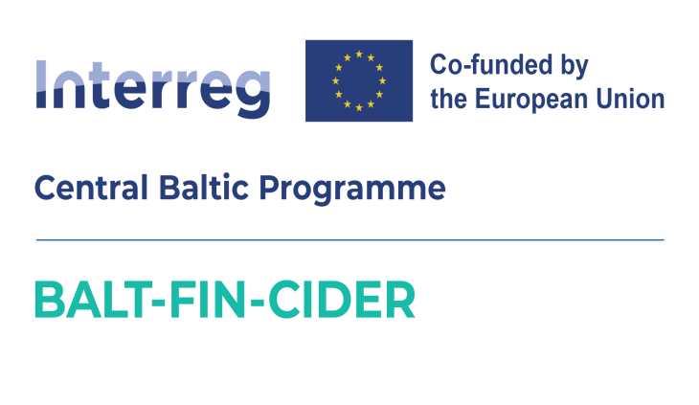

*press release 09.07.2025*

**BALTIC CIDER – Latvian, Estonian, and Finnish Craft Ciders Launch with a Joint Brand in the Australian Market**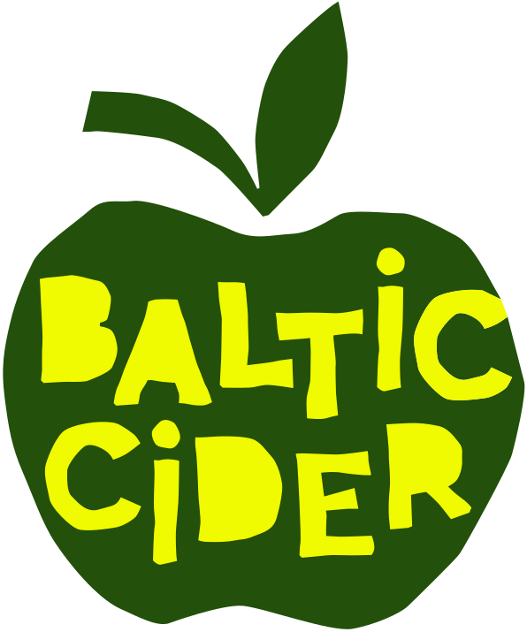

*The Baltic Cider brand was created through a joint project to open the Australian market to craft ciders from Latvia, Estonia, and Finland. As part of the project, cider makers will be invited to training sessions on export processes, while in Australia, over the course of three years, special marketing and tasting events will be organized to introduce potential distributors to the Baltic Cider brand ciders.*

*More information on how to apply to the Baltic Cider brand:* [*https://www.celotajs.lv/en/news/item/view/1428*](https://www.celotajs.lv/en/news/item/view/1428)

**What is Baltic Cider?**

Currently, the Baltic Cider brand unites 18 cider makers from Latvia, Estonia, and Finland, who produce various styles and flavors of cider from freshly pressed local apple juice and other natural ingredients – without concentrates or artificial additives. Our unique hallmark is the rich flavor, as the cider is mainly made from pure apple juice. Many cider makers grow their own apples and curate collections of specially selected cider apple varieties. The Baltic Cider lineup includes sweet, semi-sweet, semi-dry, dry ciders, and also non-alcoholic options – reflecting the diversity of cider traditions in the region.

More about Baltic Cider, the production process, upcoming events, news, cider culture, and opportunities to visit cideries for tours and tastings can be found on the brand’s website: [www.balticcider.com](http://www.balticcider.com).

**Baltic Cider to Participate in Australia's Largest Cider Competition**

In October, Baltic Cider will participate as an international guest in the Australian Cider Awards. We are submitting a wide selection of 36 cider varieties from 18 producers to determine which of our ciders best match the preferences of the Australian market. Represented cideries from Latvia include:[Mr. Plūme](https://balticcider.com/lv/cidery/mrplume), [Tālava](https://balticcider.com/lv/cidery/talava), [Mūrbūdu sidra darītava](https://balticcider.com/lv/cidery/murbudu), [Abuls](https://balticcider.com/lv/cidery/abuls), [Sabiles Sidrs](https://balticcider.com/lv/cidery/sabiles-sidrs), [Abavas](https://balticcider.com/lv/cidery/abavas), [Pienjāņi](https://balticcider.com/lv/cidery/pienjani), [Herbsts](https://balticcider.com/lv/cidery/herbsts), [Turkalnes Muiža](https://balticcider.com/lv/cidery/turkalne), [Lauskis](https://balticcider.com/lv/cidery/lauskis); from Estonia: [Tori](https://balticcider.com/lv/cidery/tori), [Kodas](https://balticcider.com/lv/cidery/kodas), [Kloostrimetsa](https://balticcider.com/lv/cidery/kloostrimetsa), [Jaanihanso](https://balticcider.com/lv/cidery/jaanihanso); and from Finland: [Lepola](https://balticcider.com/lv/cidery/lepoladrinks), Pirula, Hallonmaen, Vaski Cider.

**Presentation Events in Australia**

Seven cider makers, along with the project team, will travel to Australia to represent the Baltic Cider community and personally introduce their ciders to potential distributors, industry professionals, and the media at masterclasses and tasting events. The programme is organised with the kind help of Cider Australia, the peak body for the cider and perry industries in Australia. In collaboration with the Investment and Development Agency of Latvia (LIAA) in Australia, we are planning events at the Latvian and Estonian houses in Melbourne and Sydney, and will also visit the Finnish Embassy in Sydney. Meetings with retailers, restaurants, pubs, and visits to Australian cideries are also on the agenda.

**Export Training for Cider Makers – for Both Experienced and Newcomers**

As part of the project, training will be offered covering export processes, including technical aspects such as Australian requirements for cider composition, labeling, and alcohol content, as well as topics related to cider production, quality assurance, and marketing.

The training will be led by internationally recognized cider experts – industry authorities with extensive experience. The seminars will be open not only to seasoned cider makers but also to those just entering the cider world – individuals seeking knowledge, inspiration, and connections with fellow cider makers from the Baltic region and beyond.

**Outstanding Quality**

What encourages us to take on distant markets is the high quality of our ciders, proven by numerous medals at international cider competitions. The most recent achievements include medals at the prestigious Cider World Award 2025, organized by Cider World Frankfurt:

* Gold medal: “DACE” cider by Mr. Plūme Cidery
* Silver medals: Aronia Cider and Oak Aged Cider from Mūrbūdu Cidery, and Semi-Dry Apple Cider from Sabiles Sidrs.

**You Are Welcome to Visit Our Cideries!**

In Latvia, these and other excellent award-winning ciders can be tasted by visiting cider makers along the Latvian Cider Route, which invites you to discover truly authentic cider made from locally grown apples and to experience cider-making as an exciting lifestyle. Cider tastes best when served with the cider maker’s own story – about the apples, the fermentation, and the cider’s journey. Come visit, meet the maker, and taste genuine Latvian cider!

More information: www.celotajs.lv/sidracels (available in Latvian and English).

**About the Project**

The BALT-FIN-CIDER project aims to initiate the export of authentic apple cider produced in Latvia, Estonia, and Finland to Australia under a joint Baltic-Finnish cider brand. The project is initiated by the Latvian Country Tourism Association “Lauku ceļotājs”.

Follow project updates at: <https://www.celotajs.lv/en/project/45>

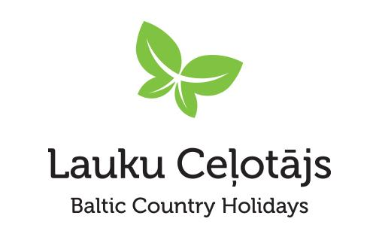

Asnāte Ziemele

LLTA “Lauku ceļotājs” / Baltic Cider

T.: +371 29285756

*This activity was supported as part of an Interreg Central Baltic Programme 2021-2027 project "Exports of the Baltic and Finnish Craft Ciders to Australia”, co-funded by the European Union. This publication has been produced with the financial assistance of the European Union. The contents of this publication are the sole responsibility of Latvian Country Tourism Association "Lauku celotajs" and can under no circumstances be regarded as reflecting the position of the European Union.*