RURAL TOURISM STUDY TOUR IN LATVIA

Topic: Quality system development and certification
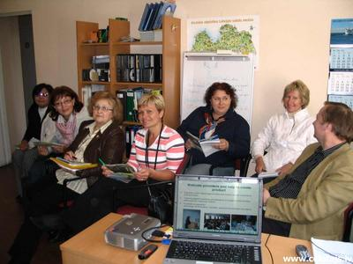

04.06.2006 / Sunday
Arrival in guest house “Alejas” (Nr. 122 in www.celotajs.lv), Riga region, 13 km from Riga
Dinner and overnight in “Alejas”

05.06.2006 / Monday
Breakfast in the guest house / Departure to Riga
Program in the office of the Latvian Country Tourism Association
Mrs. Asnate Ziemele (president),
Mrs. Antra Damberga (project manager)

- General information about the Latvian Country Tourism Association “Country Holidays” / history / main aims / activities / strategy
- Rural tourism development in Latvia, co-operation and support from the State, international institutions / ”Country Holidays” part in rural development
- Break for lunch
- Introduction with data basis and the reservation system of “Country holidays”,
- Quality and certification “Butterfly”, eco-labeling system,
- Work with owners/members, seminars, education, training materials, consultations

Departure to the country house “Bruveri” (*** Nr. 65), Sigulda, 40 km from Riga
Possibility to see other guest houses in Sigulda (“Livkalns”, “Turaidas ziedi”, “Parks”)
Dinner and overnight in “Bruveri”

06.06.2006 / Tuesday
Breakfast in the country house
Visiting and taking part in inspection work in several accommodations in Cesis region:

- guesthouse “Saulstari” (Nr. 171) and deer garden,
- self-catering cottage “Meza rozes” (***) (Nr. 35)
- coffee or lunch * in guesthouse “Lacu miga” (Nr. 571)
- Country house “Avoti” (Nr. 33)
- Cesis town – free time

Dinner and overnight in the guesthouse “Birzes” near Cesis

07.06.2006 / Wednesday
Breakfast in the guest house
Departure to Limbazi reg.

- Camping and guest house Meža salas (Nr. 728)
- Cottage “Juras maja” (Nr. 220) and country house “Duntes urdzinas” (Nr. 31)
- Manor house “Skultes muiza” (Nr. 915), guest house „Saulrieti” (Nr. 156)

Overnight and dinner in recreation complex „Pie Maijas” (Nr. 121, 141, 69, 238) discussion about the experience of previous days

08.06.2006 / Thursday
Breakfast in the guest house / Departure to Byelorussia.

