Latvia: the pilot project „Sustainability through common rural tourism quality aspects”
Latvian country Tourism Association “Lauku celotajs”, www.celotajs.lv

Rural tourism is still a comparatively new and growing part of rural economy in the Baltic countries. While celebrating the steadily growing numbers of tourists, it is a challenge now to maintain the appeal and attractiveness of the countryside protecting the resources on which rural tourism product is based. How to do it? The Pilot project proposes to regard sustainability issues in the context of rural tourism product quality, integrating sustainability aspects into a running and well recognised rural tourism quality scheme. Promotion of sustainable rural tourism products goes along.

1. Review of rural tourism product
As the first step in the project, we summarised the present rural tourism situation from the point of view of sustainability in Latvia. It was done, visiting rural tourism businesses, analysing rural tourism database and using results of the available studies, etc. The review of the situation provides a number of examples of sustainable and just opposite way of doing things in tourism. As well, actions and measures at all levels of responsibility – from policy makers and executives down to rural tourism businesses and tourists - are proposed. Some of the key conclusions are here:

- sensitive biotopes and rare species should not be included in tourism products;
- rural tourism businesses, complying with principles of sustainability, should be legally entitled to certain privileges (e.g., taxes, support, etc.);
- funding sources should be made available to activities maintaining rural heritage (skills, crafts, traditions, etc.) and its integration into contemporary rural life and rural tourism products;
- a handbook on sustainable tourism development defining actions and responsibilities at all stakeholder levels is necessary.

Based on the existing situation in Latvia and European countries, the document offers rural tourism definition (sustainability aspects included) and also defines those tourist activities which are sustainable and therefore recommendable for development support.

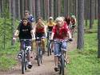 |  | 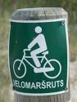 |  | 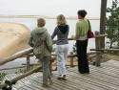 |  | 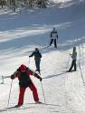 |  | 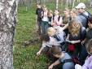 |  | 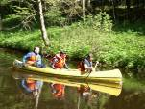

For the review, we visited rural tourism businesses – country homes, guest houses, self-catering cottages to look at their activities and impacts from sustainability point of view. During the visits, sustainability aspects were discussed with the providers.

2. Criteria of sustainable rural tourism accommodation product
The list of sustainability criteria to be included in the rural tourism quality scheme was developed based on the following:

- state-of-art in rural tourism practice
- recommendations and experience of rural tourism and environmental organisations
- indicators for sustainable tourism development in the Baltic Sea region

The criteria are integrated into rural tourism quality scheme we run since 1994, with upgrades and improvements as necessary. This way the quality scheme serves as a tool to motivate rural tourism businesses to adopt sustainable practices. The sustainability criteria are simple enough to be achievable by a rural tourism business. At present, they are the first step towards the “Green Certificate”, the Latvian ecolabel for rural tourism accommodations, and then, possibly further to the “European Flower” ecolabel. The idea is that the sustainability criteria should be periodically revised and upgraded, according to the need.

SUSTAINABILITY CRITERIA -
APPLYING TO SERVICED AND SELF-CATERING ACCOMMODATION ESTABLISHMENTS

General environmental information to guests
Provide guests with appropriate information about local nature, organic farming and local culture
(e.g. by a leaflets, guidebooks, guided trips etc.)
Provide guests with information on sustainable behaviour
(what they can do and what should not do to protect the surrounding nature and environment – e.g., not to disturb birds and animals, comply with fishing regulations, make bonfires only in designated places, etc.)
Support of environment friendly agriculture
Locally produced food products are offered to tourists
Green building policy
Maximum use of environment and human friendly materials in case of new constructions or renovations.
The landscape and regional architecture traditions are respected in case of new constructions or renovations.
Reduction of waste
Disposable tableware and other single use items are not used.
Waste is disposed according to the local administrative regulations (e.g. a contract with a waste management company)
Active contribution to sustain cultural heritage
Traditional building techniques are respected in case of new constructions or renovations
Active contribution to local economy
Co-operation with local providers/services (food, souvenirs, production, etc.)
Improvement of environmental performance
Continuous attention to environmental impact of the establishment, improvement of environment and nature protection measures.

We have inserted these sustainability criteria into our web based quality system tool which provides assessment of a quality category based on the data entered into the inspection form. Accessible at http://www.kvalitate.celotajs.lv/quality_rt/main/ (password/login: demo/demo), the tool is being constantly improved.

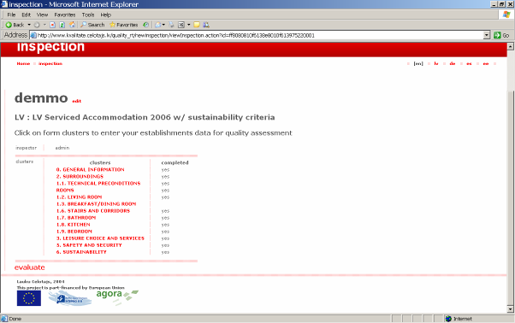

Inspection form
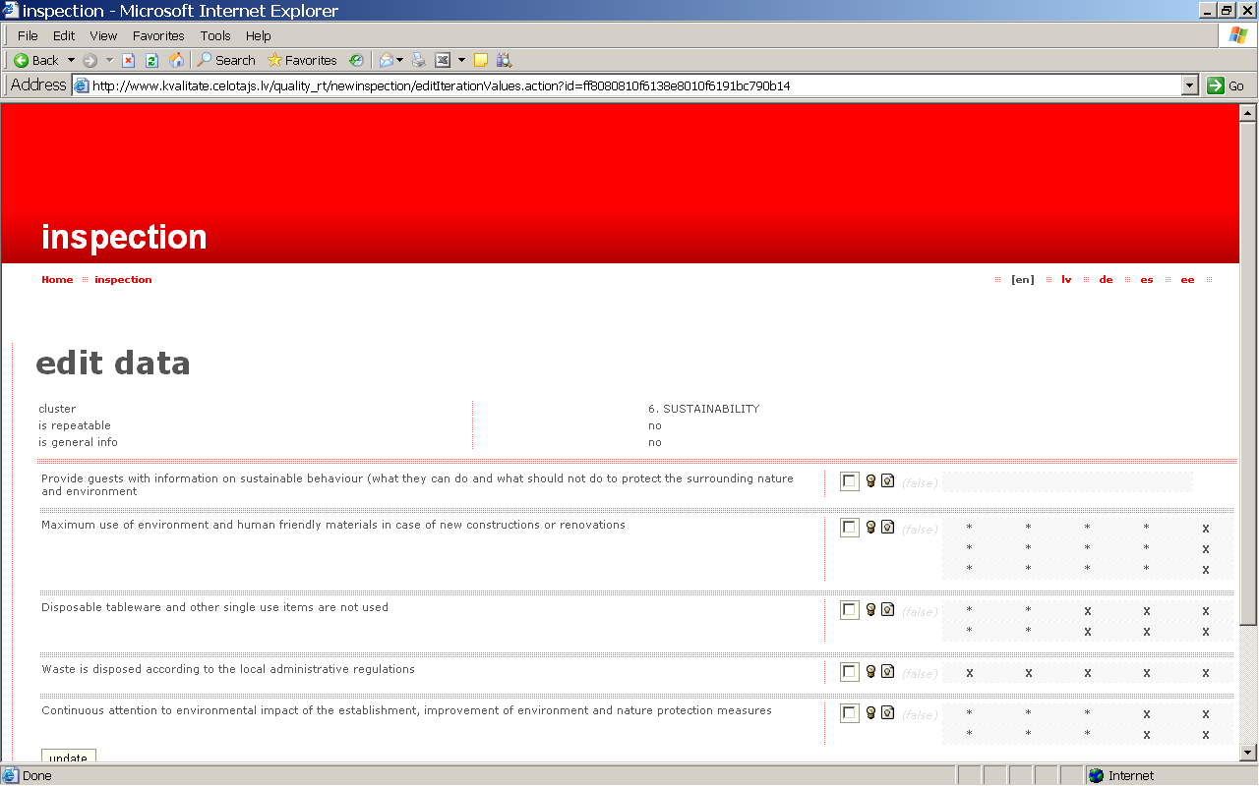

Inspection form – data entry, sustainability cluster

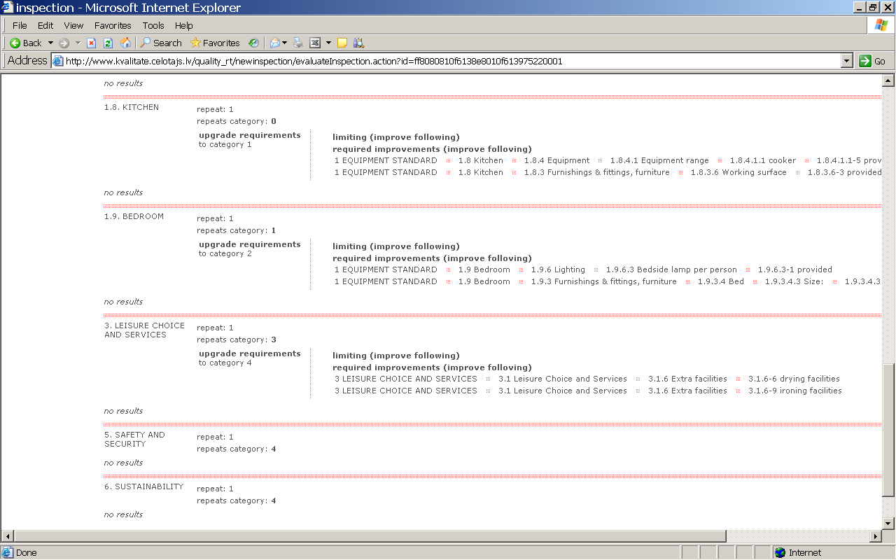

Assessment report showing the assigned category of quality by clusters

3. Promotion of sustainable rural tourism products
To promote sustainable rural tourism products, the “Green Holidays” brand has been introduced. For better promotion, the products have been grouped around specialisations and are marked with pictograms in the printed promotional publications and the web site www.celotajs.lv :

 |  |  |  |  |  |  | 
 | fishing | horse riding | seminars | wellness | parties | for kids | skiing

The main promotional activities and means are the following:

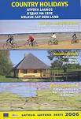 | - The country holiday catalogue, which is distributed to general public
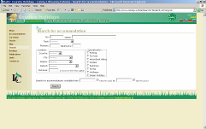 |  | 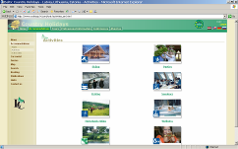
- The website www.celotajs.lv ; www.countryholidays.lv where specialisations and Green Holidays are described for consumers, and it is possible to search by specialisations.

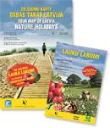 | - The map “Nature holidays” with the guide “Countryside Bounty”. The map promotes those nature attractions which have been adequately prepared for tourists to avoid harm and damage. The “Countryside Bounty” concept involves in tourism activities small open farms, craftsmen workshops, and all kinds of small and micro production businesses in the countryside. Putting on one map rural accommodations, “Countryside Bounty” farms and those nature attractions which are managed in environment friendly way, we are promoting rural tourism which balances economical, social and environmental aspects.
4. Dissemination activities

The concept of sustainability in rural tourism has been widely promoted, first, among rural tourism providers.

- Providers can find information in the professional information section in the web site www.celotajs.lv , where the sustainability criteria are available as a download.

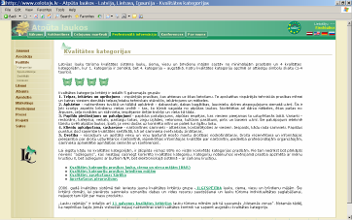 | 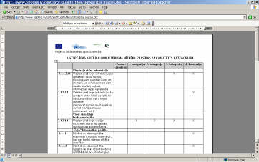
- The AGORA project and the pilot project activities have been presented to the audience of more than 300 rural tourism providers, educationalists, municipality representatives, tourism professionals, mass media and other interested bodies in the conference (February 3, 2006).

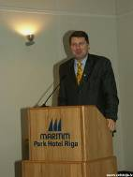 | 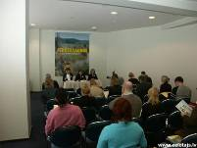 | 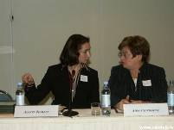 | 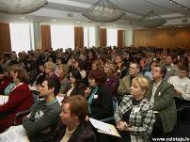
Raimonds Vējonis,  the minister of Environment, opening the conference | Press conference | Asnate Ziemele (LLTA „Lauku ceļotājs”) and  Aira Andriksone (ministry of Economics) | Conference participants

- A seminar on sustainability issues for rural tourism providers was held in Saldus region (April 26, 2006). The seminar was attended by 61 participants. Sustainability criteria were introduced as part of the quality system and compliance requirements explained to participants. The participants were asked to fill in a sustainability test, based on the sustainability criteria in order to enhance provider understanding and motivation. The test results show that the majority of the providers already now practice many of the measures which are required to qualify as a sustainable operation according to the present criteria.

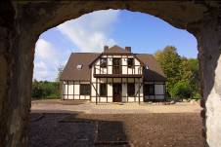 | 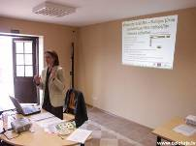 | 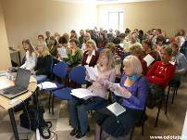
Seminar venue – the Smuku estate | Asnate Ziemele presenting the AGORA project and sustainability criteria for rural tourism businesses | Seminar participants

- The project aims and activities have been discussed and promoted also through visiting rural tourism operations in Latvia, Lithuania and Estonia, participating in the events like the 1st congress of Latvian-Lithuanian Forum (21.-22.09.2005), Rural Tourism conference in Lithuania (7.12.2005.), the meeting organised by ECOTRANS, the international network of sustainable tourism experts (2.-4.12.2005. Germany), the WTO conference "Impact of European Union Enlargement on Tourism Development in Europe" (2.-3.03., 2006. Lithuania), and other.

- Presentation of the “Nature Holidays” map with the “Countryside Bounty” map took place on 06.10.2006. in the ministry of Environment. With 150 participants, addressed by Raimonds Vējonis, the minister of Environment and Nina Rakstina, the head of Rural Development department of the ministry of Agriculture, the event was an encouraging demonstration of project achievements. It proved the recognition of the sustainable tourism initiatives at the ministry level and also the great enthusiasm of the participants who made a perfect showroom of the “Countryside Bounty” products, the whole event carrying a friendly and optimistic atmosphere.

- Project progress and results are found in http://www.celotajs.lv/cont/prof/proj/Agora/Agora_en.html

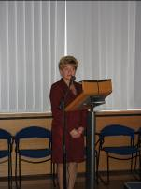 | 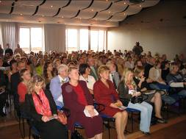 | 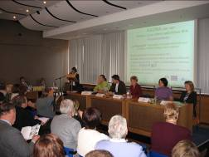
Nina Rakstina, the head of Rural Development department of the ministry of Agriculture addressing the participants | Presentation participants | Antra Damberga presenting the AGORA project to participants
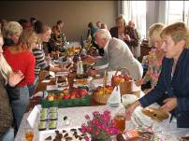 | 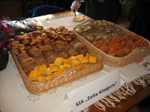 | 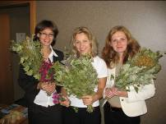
„Countryside Bounty” demonstration | „Countryside Bounty” demonstration | „Countryside Bounty” demonstration



