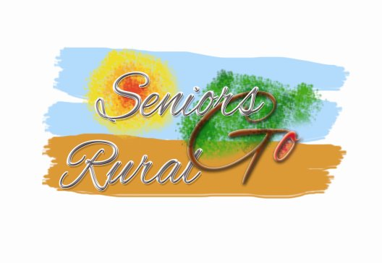

**Seniors Go Rural** (SenGoR)

Final European Workshop on Low Season Senior Tourism in Rural Areas

5th-February-2016, 9:30-16:00

**Hotel Pitti Palace Ponte Vecchio - Florence** (IT)

**PROGRAMME**

**THURSDAY, 4th-February**

During the day Arrival of participants

Participation at conference “Europe: the best destination for seniors” *(optional)*

19:00 Get-together Dinner with participants of the conference

**FRIDAY, 5th-February**

9:30 Welcoming of the participants and quick round of personal introductions

9:45 Overview of the results from the Seniors Go Rural project   
*Ms Asnate Ziemele – Project Leader*

10:00 Presentation and discussion of the Product development guidelines and criteria “Senior Tourism – Rural Tourism Low-Season Product”  
*Mr Klaus Ehrlich - EuroGites*

11:00 Coffee break

11:20 The Silver Suitcase system: accreditation, logo, framework agreements

12:10 Presentation of the website <http://sengor.eurogites.org> and its functionalities

13:00 Working Lunch

14:00 What comes next? – discussion of the exploitation options

* Registration of the logo as European Trademark
* Development of accreditation and new products in other countries
* Management, use, and future development of the website
* Long-term sustainability
* Cooperation, joint criteria, and common action with other parallel projects

15:45 Summary results

16:00 End of the Workshop