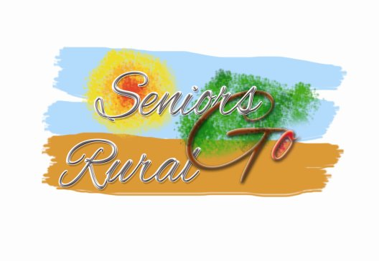

**Seniors Go Rural** (SenGoR)

Final European Workshop on Low Season Senior Tourism in Rural Areas

5th-February-2016, 9:30-16:00

**Hotel Pitti Palace Ponte Vecchio - Florence** (IT)

**MINUTES**

**Participants:** Bruno Bernabé – Gites de France

Klaus Ehrlich – EuroGites

Hans Embacher – Austrian Farmholidays

Patrick Farjas – Gites de France

Aneta Mazurek – Polish Federation of Hospitable Farms

Panos Poulos – SEAGE Greece

Jan Tjosaas – HANEN

Andrew Woodward - FarmStayUK

Linas Zabaliunas – Lithuanian Countryside Tourism Association

Asnate Ziemele – Lauku Celotajs

Ms Asnate Ziemele welcomed all participants to this final European Workshop on Low Season Senior Tourism in Rural Areas. She shortly explained the agenda. This was followed by personal introductions of the other participants.

**Overview of the results from the Seniors Go Rural project**

The presentation of the project focus, work done, and results as given already the previous day at the Conference was repeated to provide a framework orientation.

**Presentation and discussion of the Product development guidelines and criteria *“Senior Tourism – Rural Tourism Low-Season Product”***

The most recent version of the guidelines was distributed amongst the participants. Most of them already had basic knowledge about the content of these guidelines because they had been involved in the revision of the first draft in autumn 2015.

Following the feedback that had been received from the client / user survey conducted in January, and coincident experiences from the other parallel projects as presented the previous day in two events (internal and conference), it was agreed to revise the content of the guidelines in the following lines:

* Reduce the strong stress on different levels of mobility
* Avoid the term “Senior” and substitute it by “55+ aged” or similar, at least in material that addresses the public / clients
* Extend the criteria to “soft” and experience-related aspects such as leisure services, activities, contact with local culture and population, and CSR

Other related materials (brochures for clients and providers) shall be revised in focus and content accordingly. In the information to providers, special mention will be made to include criteria into promotion and communication in a subtle way, avoiding the impression that products are specific to seniors or 55+ aged persons.

It was also commented that the recommendations and guidelines, while not complicated to implement, will nevertheless require the availability of more detailed assessment and advisory services, as well as specific training.

***Coffee break***

**The Silver Suitcase system: accreditation, logo, framework agreements**

Presentation of the revised logo “Silver Suitcase”, and the options for future use (to be discussed after lunch). At this stage, the use of this logo is free and no formal rules are set; EuroGites will be the exclusive owner as was agreed in the project meeting the previous day. However, interest from third-party was detected (especially from the ESCAPE project) and future common action is possible.

The framework agreements were explained and discussed, with minor amendments over the existing versions to be incorporated regarding the options of either discounts or other free added-value (“freebe”) services. Unless formal rules for the use of the logo are established in the context of possible branding, EuroGites can decide and define how the logo may be used by its members.

**Presentation of the website** [**http://sengor.eurogites.org**](http://sengor.eurogites.org) **and its functionalities**

The final testing version of the website was presented, yet with little content due to the recent “Go Live” and several technical problems that need to be solved in the coming weeks.

The website is specific for Senior-Friendly Tourism Products in rural tourism, under the control and management of EuroGites that owns the code. Authorised users – in general, members of EuroGites – can directly introduce their products and offers on the site.

As per now, content will be limited to the test products that were prepared during the project in Norway, Latvia, Lithuania, and Belgium. However the potential of the site allows extending to any other country and also to geo-regions such as “Baltics”, “Alps”, etc. Booking facilities are technically possible, but not operational, this will require further decision by EuroGites that is only possible after end of the project.

***Working Lunch***

**What comes next? – discussion on the exploitation options**

* Registration of the logo as European Trademark. The logo is attractive and has found good response from third party. Therefore it the idea of a formal protection through registration as a European Trademark by EuroGites was unanimously supported, regardless future use or transformation into a Collective Mark.
* Development of accreditation and new products in other countries. The conceptual framework through criteria, logo, and promotion tool (website) is in place. For the moment, several members of EuroGites showed interest in a future use. On a national level (Latvia), promising initiatives were already started. A wider uptake and – especially – the objective to address international markets raises the question of formal rules and accreditation to assure the reliability and confidence of clients, this will be outlined in the Exploitation Plan. As minimum, internal rules within EuroGites shall be set up and decided at the upcoming General Assembly in late spring 2016.
* Management, use, and future development of the website. Management and hosting requirements of the new website exceed considerably the actual level of the EuroGites site. The site can remain as-is, but for a vivid and attractive future use the uptake and use by member organisations is critical. Resources for special training and support will need to be assigned, a semi-commercial use (ie. by charging a fee for each promoted product) is included as one option in the Exploitation Plan, but need to be approved by the General Assembly later in 2016.
* Long-term sustainability - Cooperation, joint criteria, and common action with other parallel projects. Apart from the use of SenGoR outcomes by EuroGites, conversations with other parallel projects for joint action were initiated. In general, the idea of an international common action with external entities (such as OITS or ESCAPE consortium) was already considered positively in a four-project meeting the previous day, and participants at this workshop agree that negotiations in this sense should be continued to generate a critical mass.

The workshop finished at 16:00 with informal get-together over a second coffee break by courtesy of the venue.