Guidelines for customer feedback gathering

We recommend to use booking systems – booking.com, tripadvisor.com etc. to collect the client feedbacks. Many booking systems are connected with tripadvisor.com, so there will be the same feedbacks. Totally there should be 100 feedbacks for each partnercountry connected with safety and security.

- Booking .com customer feedbacks

To gather the costumer feedbacks in Booking.com, in the left corner enter area of the country and tick that you do not have specific dates yet. Search will open all accommodations in the current region. Choose the accommodation which has evaluation and score, as they do have feedbacks. Ones without score are newly listed and do not have feedbacks yet.
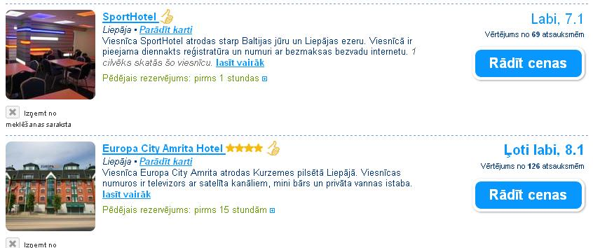

To check the current accommodation feedbacks click on the evaluation and score. Read the feedbacks to find ones which are related to safety and security. Feedbacks related to these aspects enter in “Customer Security Feedback Survey”. NB – as in booking.com it is not possible to copy current feedback link, please enter the link where can see all feedbacks for this accommodation. Date of the stay can see under the name of person who has written the feedback.
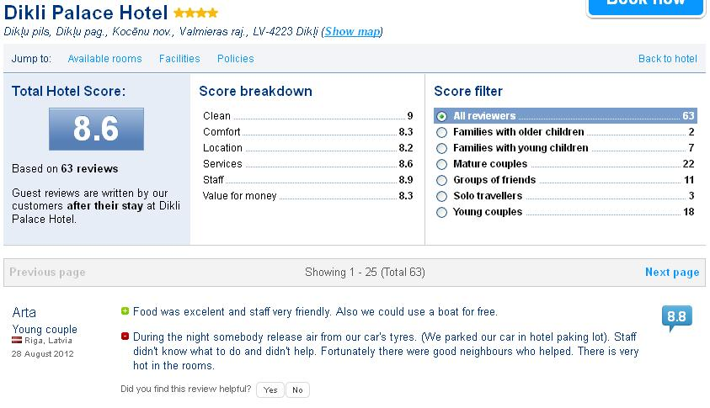
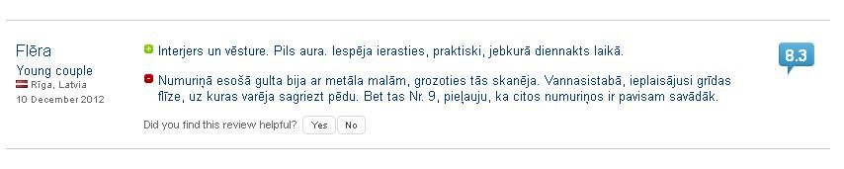
- Tripadvisor feedbacks
Open webpage http://www.tripadvisor.com/ and enter region in the left corner to view all hotel in the area. Feedbacks can find if you click on the name of accommodation and then roll down. Our experience shows that in this webpage more common are good reviews.
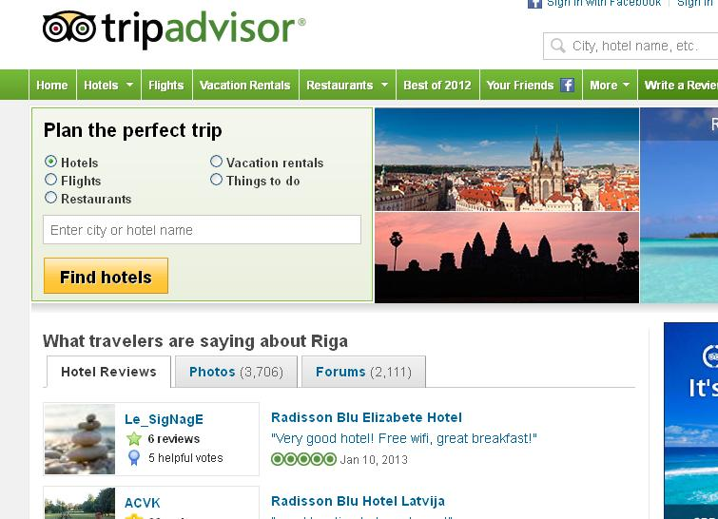
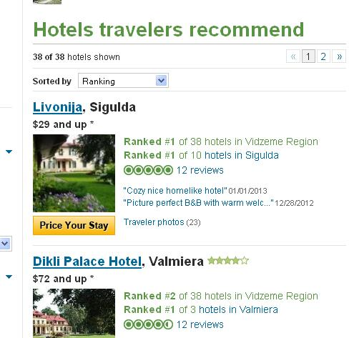
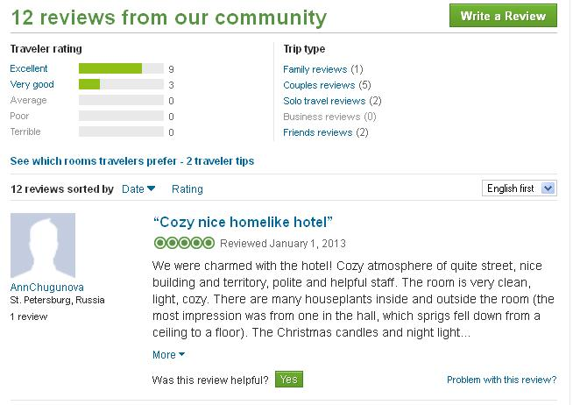
- Your country specific travel portals
To collect more feedbacks use webpages of national country tourism organizations and other available in your country.
- Risk prevention in workplace - sources of feedback
Feedbacks connected with risk prevention in tourism as a workplace we searched in google.com with key names in national language – hotel, job, vacancy, amount of work etc.

- Customer Security Feedback Survey – example
Every feedback should be entered here: https://docs.google.com/spreadsheet/viewform?formkey=dDFaRXRUZndRa0dMVEFaYWpsNFFuZkE6MQ#gid=0
Feedback should be pasted in original language and text related with security and safety translated to English and pasted in field – “Abstract in English”.
In section “Analysis of feedback” tick the indicators related to feedback. If in given choice there is no related indicator, please write it in section “other positive security feedback” or “other negative security feedback”.
After filling all information press “submit” to save the information.
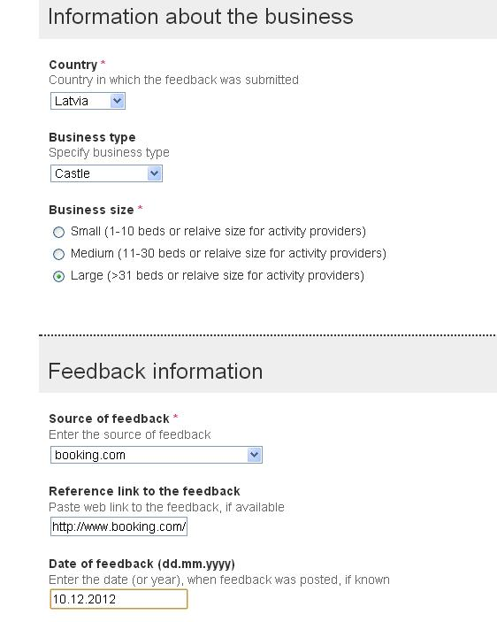
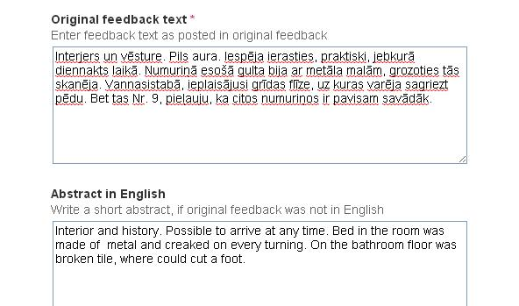

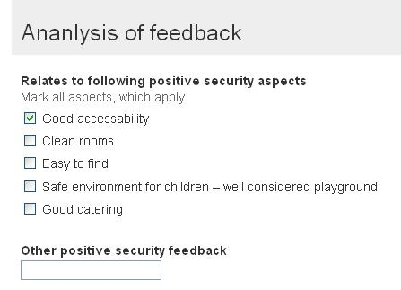

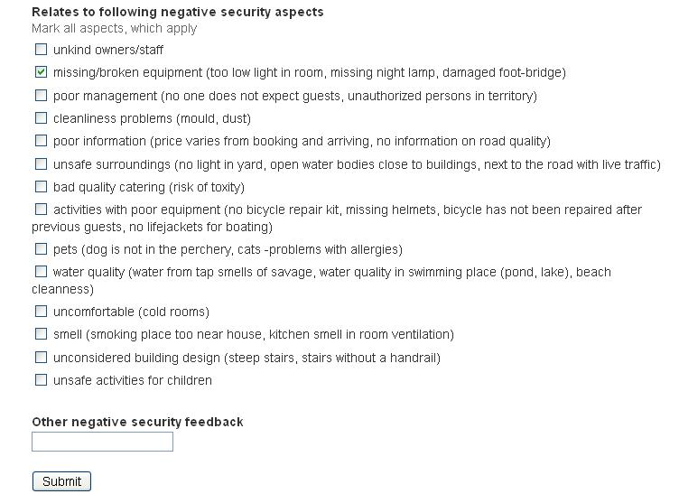

- Feedback examples

“During the night somebody release air from our car's tyres. (We parked our car in hotel paking lot). Staff didn't know what to do and didn't help. Fortunately there were good neighbours who helped. There is very hot in the rooms.”

“Place for smokers are on balcony or just outside the entrance which means tobacco smoke comes into the room if window is open. The hotel could considering to move the smoking spot a bit further away from the building as the yard has plenty of room.”

“Furniture in room completely worn out with big holes in upholstery Smoke from chimney comming in room with window open and ciarette smoke comming in non smoking room through bathroom vent fan if room was no smoking ,why ashtray in room ? This kind of service is deceiving the customer,that arrives late and can not find another hotel. Management is indifferent to the customer,it is like rip me off once and you will never see me again. Latvia does not understand tourism business.”

 With support of the Lifelong Learning Program of the European Union.
This publication reflects the views only of the author, and the Commission cannot be held responsible for any use which made be made of the information contained therein.

