Project “Practice based training tool for safety and security in European rural tourism”
SAFETUR, 2012-1-LV1-LEO05-03389
4th Partner meeting
Scandic Hotel, Bergen, Norway 26.05.2014

8.45 Meet in the hotel meeting room. Please, do not be late to meet the next guest speaker!!!

9.00 Example of Safety aspects in Rural-active tourism enterprise in Norway. Ekstremsportveko www.ekstremsportveko.com , discussions. Sofie Torlei Olsen , manager

Coffee

10.00 - 12.00 Project results reached:
- Customer survey – State of art and findings
- Handbook and Inspection Manual European version
Asnate Ziemele, Project leader / Klaus Ehrlich, Eurogites
- Handbooks from partner countries, differences, findings, usability…
Each project partner shortly presents their version
- Dissemination on Safetur within each partner organizations and countries (minimum activities per partner: two press releases, publication at website and link to project website, two workshops)
- Involvement of the training institutions – partners reports their activities according to LV NA interim report comments
Each project partner presents their activities – done or planned
- RT Congress in Austria – Safetour dissemination main event. How can we present it?
Klaus Ehrlich, Eurogites

12.00 Lunch break

13.00 Next tasks, deadlines, results:
- Designed full version of Handbook for European version and partner versions 06.2014
Asnate Ziemele, project leader
- Testing Handbook and tools with rural tourism providers and VET students, report on testing results sent to leading partner – 06.2014
partners to present testing plans
- Results to be transferred to Eurogites, published on the web – 07.2014
Klaus Ehrlich, Eurogites
- Online tool with three parts: Safety&Security check, inspection manual, virtual training module with criteria and photos – 01.09.2014
Girts Ziemelis, IT specialist
Coffee.
15.30 Financial issues, final report 30.10.2014 preparation, deadlines.
Kristine Petersone, accountant

16.30 End of meeting.
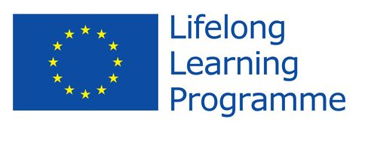
This project has been funded with support from the European Comission.
This publication reflects the views only of the author, and the Commission cannot be held responsible for any use which made be made of the information contained therein.

