PARTNERS AND supporters
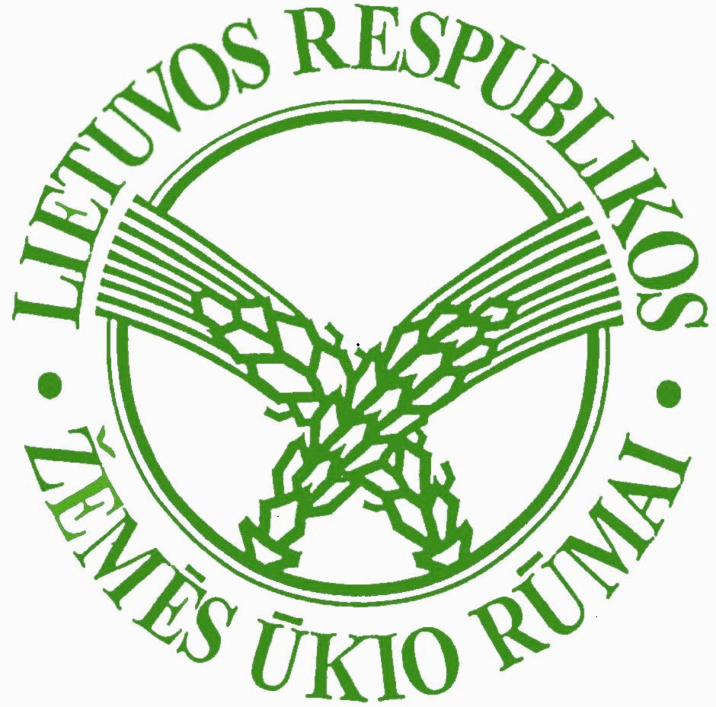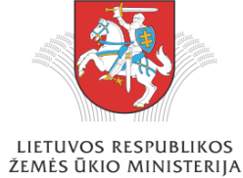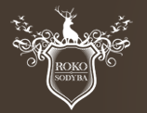

information supporters

CONFERENCE PROGRAMME (it may be change):
10.30-11.00 Registration
11.00-11.15 Presentation “Alternative trades in a village - not outgoing opportunities”, R. Sirusiene-Lamauskiene
11.15-11.35 Presentation “Connection between rural tourism and architecture heritage”, J. Bucas
11.35-11.55 Honor of contest “Lithuanian rural tourism homestead”
11.55-12.15 Presentation “Partnership developing tourism and regional products: experience of COTOUR project”, V. Atkociuniene
12.15-12.35 Presentation “Rural tourism homestead - development of start-up organization”, B. Svagzdiene
12.35-12.55 Presentation “National and EU support for rural tourism. Present and future support for rural tourism, encampment, handicraft bartons”, LR ministery of agriculture
12.55-13.10 Coffee break
13.10-13.30 Presentation “The Baltic countries and EU rural tourism experience”, J.Smaļinskis
13.30-13.50 Presentation “Byelorussian first rural tourism work stage - successes and ill successes”, V. Klitsounova
13.50-14.20 A lively discussion: Is rural tourism on the right way? What rural tourism does the guest want to see? Is the right attitude of our state to small trade in a village? What dangers do you see which could harm rural tourism in the future?
14.20-14.30 Resolution
Countryside tourism association of Lithuania

Rural tourism development
(national and international experience)


Date of conference: 2009-11-26 11.00 h.

Place of conference: “Roko sodyba”, Stasiūnų k., Žiežmarių sen., Kaišiadorių r.
(arrival scheme is enclosed)

Information:
8-37 400354 arba el.paštu kaimas@zur.lt
(Živilė Orlovienė, Vėjūna Michailovaitė)

Arrival scheme
