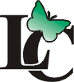
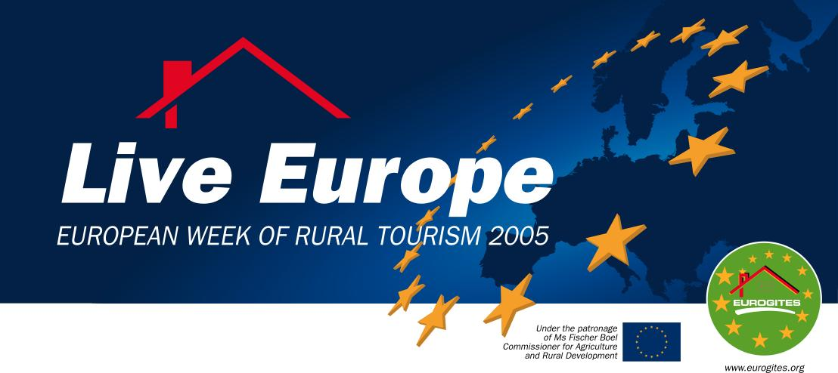

European week of rural tourism
October 7-16, 2005

PRESS RELEASE

European Action Week Rural Tourism 2005 is a new initiative of ”EuroGites”, the European Federation of Farm and Village Tourism, among members of which is the Latvian Country Tourism Association „Lauku celotajs”. Activities to promote rural tourism as an attractive offer and quality assured service which is enjoyable also in off-season will take place in October 7th to 16th. The Action week also aims at drawing public attention to the problems present in the sector.

Official opening of the Action Week with a video conference will be held in October 7th in Nantes (FR). Ms. Mariann Fischer-Boel, the EU Agricultural Commissioner, will address the audience. Heads of European rural tourism associations will discuss the common problems and future prospects.

Surprises and special bonuses for countryside visitors
Tourists, staying during this week in rural holiday sites in a number of European countries, can expect a pleasant surprise – the hosts will present them with a small gift, characteristic of the given country, region or locality, like a bottle of wine and some cheese in the region of Bordeaux, France, local artisans’ products in Romania, free guided excursions in Spain, etc.

Also rural tourism providers in Latvia have something special in mind for their guests during the Action Week. Just some examples: guests at the vacation cottage “Meztini” in Talsi region will get locally produced goat cheese. Those staying the country house ”Murnieki” in Aluksne region will be given a bottle of home-made apple juice. Other free gifts are: smoked fish from the hotel ”Roja”, herb tea bags from country house „Bruveri” in Sigulda, honey, eggs from own farm, or even a live rabbit from the owners of the „Apsisi” cottage in Talsi region, a bag with apples, a souvenir from Ventspils city or a pancake meal for free from the guesthouse „Pulkvedis” in Ventspils, honey from “Brivini” and ”Dravnieki” farms, apples, honey or woodcarvings by the host at country house “Kalna Bauni” in Valka region, free sauna at guesthouse “Ezerrozes” and cottage „Pie Raznas”, mini-golf in „Vecmuize, Limbazi region, Jacuzzi for free at “Pukkalniņi”, Ogre region, and other sincere countryside gifts.

„Lauku celotajs”, the Latvian country tourism association, will offer a 10% discount on bookings for the Action Week.

Photography contest
„Lauku celotajs” invites all countryside visitors to send photos showing their best, most exciting and funniest moments from holidays in the Latvian countryside. Deadline – October 31.

All photos will be put on the website www.celotajs.lv, and the author of the most attractive photo will get the prize – a free weekend accommodation for two persons in a country house, guesthouse or a vacation cottage in Latvia any weekend, except seasonal holidays, by May 1, 2006.

The photos can be sent by e-mail lauku@celotajs.lv or by post to „Lauku celotajs” Kugu str. 11, Riga LV-1048.

Facts on rural tourism in Europe and in Latvia
The sector of rural tourism provides more than 400.000 accommodation units with 4.000.000 bedspaces. In Latvia, the database of “Lauku celotajs” contains ca 300 accommodation units with ca 5000 bedspaces. According to EuroGites, the total impact of this sector to the rural economy is well above 150.000 million EUR. “Lauku celotajs” estimates that tourists have spent ca 3.000.000 Ls on overnighting in rural accommodations in Latvia. The actual impact is even higher, as this figure does not include meal services, holiday activities and other services.

Current rural tourism issues in Latvia
In the context of the European week of rural tourism, „Lauku celotajs” wants to draw public attention to the current problems and their eventual solutions in Latvia:
- Formulation of rural tourism and rural tourism accommodation definitions and their approval in legislation. These definitions should be set by Law as today, all tourism business activities outside Riga, the capital, are regarded as rural tourism. Such interpretation degrades the very essence of rural tourism concept and does not allow to achieve tax reductions for small scale rural tourism operations, as it is in European practice. The rural tourism definition, offered by „Lauku celotajs” is based on the definition provided by the EuroGites, which is already enforced by law in Lithuania and under official approval process in Estonia.
- Distribution of the “Good Hygiene Practice Guidelines for Food Service in Rural Tourism Establishments in Latvia”, approved by the Food and Veterinary Service, and organization of seminars to implement the guidelines in practice and facilitate provision of food service in rural tourism establishments.
- Implementation of the new rural tourism quality system and introduction of the new quality symbol – a butterfly. The new system is designed to support and guide rural tourism providers in their efforts to achieve higher quality of facilities and services and to improve the overall level of rural tourism quality in Latvia.
- Incorporation of „green” or sustainability criteria in rural tourism quality system to direct the development of rural tourism in Latvia towards sustainability, maintain regional character, respect capacity of local natural resources and natural landscapes, and build rural tourism offer, based on the local social, natural and cultural resources.

By Agnese Jakoviča
Marketing manager, Association „Lauku celotajs”
T: 7617024
agnese@celotajs.lv
www.celotajs.lv

