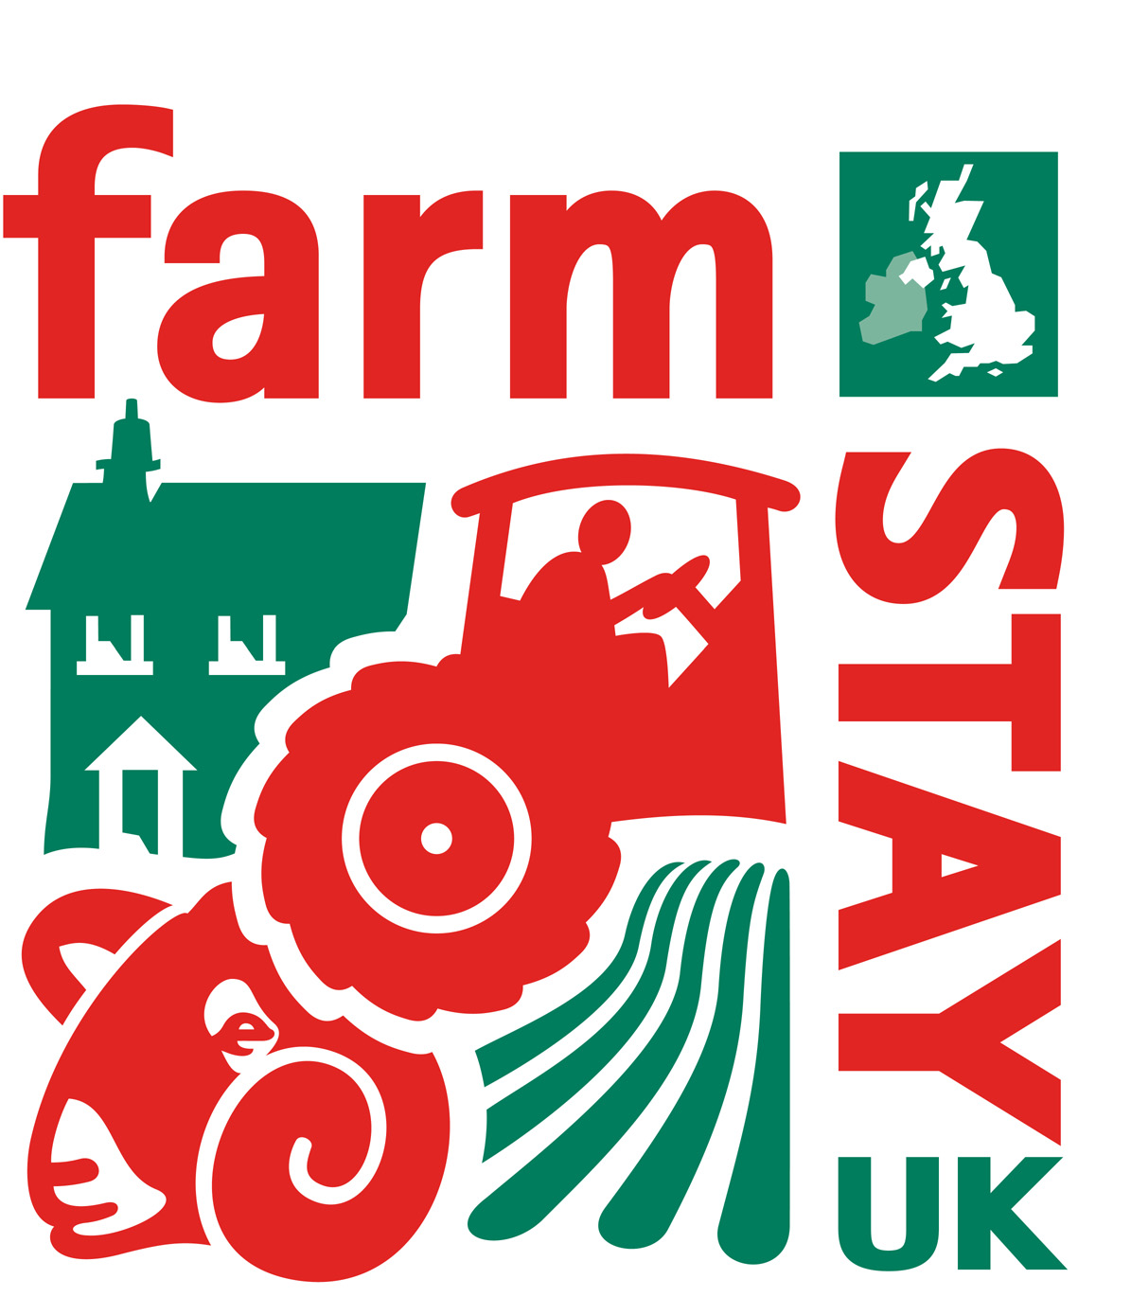

1 June 2010

Commentary for Farm Stay UK presentation

Slide 1

Andy Woodward is Chief Executive of farm Stay UK. He represents 1,200 properties that are all on working farms. 750 are bed and breakfasts and 550 are cottages or self-catering.

Farm Stay was formed in 1983 and is over 25 years old.

Slide 2

There is a definite trend towards the countryside in the UK. Concerns over food production and the environment are very topical and this is driving consumer demand and being reflected in the media.

The TV schedule is now offering more and more exposure to the countryside either directly reporting on countryside activity or through food shows. There is even a new B&B show called Three in A Bed where 3 B&B owners compete to see who offers the best value for money.

There is also a trend for “GLAMPING” which is GLAmorous caMPING. This includes staying in posh tents – more of which later.

Slide 3

The reality is that the worldwide recession is keeping people at home. Even though the UK is not cheap, it is knowing how to budget locally that keeps people at home in times of crisis.

The main difference to the 1970’s recession is also that holidays are now a “necessity” and not a “luxury” and people are reluctant to give up their annual trip.

We have also had a General election resulting in a new centre / right government and there is a small football tournament about to happen in South Africa!

It has meant that bookings are coming very very late – but we are confident that they will come.

Slide 4

2009 did show a remarkable trend towards holidaying in the UK – the Stay-cation – with 17% more holiday trips being taken than in 2008.

However the increase in seaside visits still outstripped country / village holidays which still increased by over 10%.

Although camping and caravanning increased significantly, the increase in expenditure was still under 4%.

Slide 5

So what is new?

We have people building houses and cabins from straw bales.

The caravan is actually a mobile home trailor which allowed the owner to avoid planning permission. However the planners like what she had done and then gave her planning permission for the cottage.

The walls are plastered on the inside and have breathable lime render on the outside to allow movement.

Slide 6

The other trend is for “glamping” and I am taking my family to this Yurt in under a month’s time. It is camping with luxury attached and one of the other yurts on this farm has a Jacuzzi tub run by a heat exchanger in the ground.

You can see it has a double bed, wood stove and an outside bath!

Other people are offering tipi’s (teepees) and wigwams.

Slide 7

Looking for new marketing partners

The trend for staycations and the countryside has led us to new marketing opportunities. The biggest has been a major promotion with our leading yoghurt supplier, Muller.

They purchased nearly £100,000 worth of holidays from us and promoted us on 13 million packs of yoghurt.

The results have been amazing for our brand awareness.

This summer we will be seen on 50,000 packs of lamb in a major supermarket chain.
Slide 8

This is an example of the prize voucher we gave away.

We split the £1,000 prize into £200 vouchers so that the winner could either take 1 big holiday or a number of small ones.

Slide 9

We have also started to seek EU funding. For us this is via the Rural Development programme for England, RDPE.

Our first success has been in the West Midlands of England offering us £200,000 over the next 3 years.

Our aim is to improve the interpretation of the farms to enhance the visitor experience.

Our branding has also allowed us to approach and secure a relationship with the BBC’s most popular childrens character, Shaun the Sheep, who is from the same production company as Wallace and Grommit, who you may have seen.

Slide 10

We hope that Shaun will attract children to pester their parents to take them to the countryside.

Slide 11

Andy finally, it is important that we do not lose sight of what we already have. We have a lot of historic buildings that many people of all generations have never stayed in, just to wander in the fields and the countryside.

All our members have to be graded by their national tourism agency or the AA, the food is always great

And it makes for very happy customers.

Thank You

