Product development guidelines and criteria

SENIOR TOURISM -
RURAL TOURISM PRODUCT

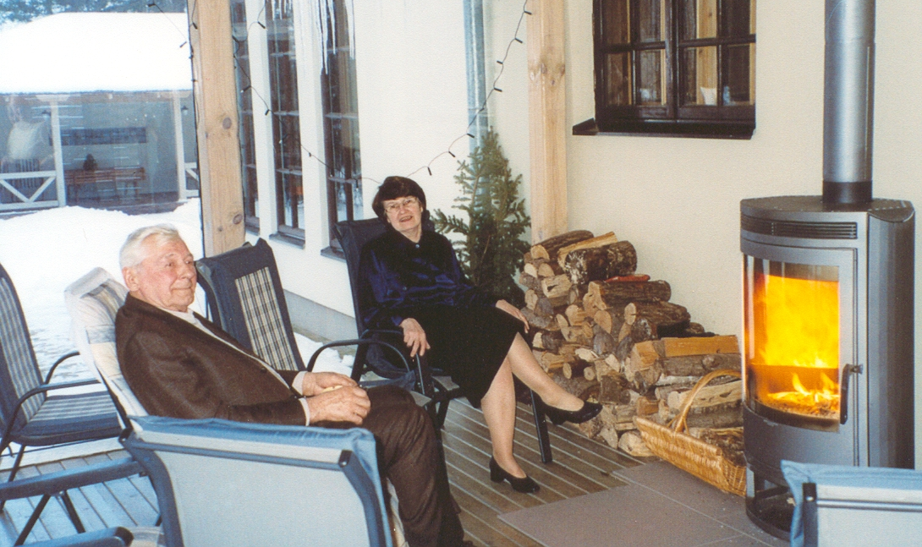 | 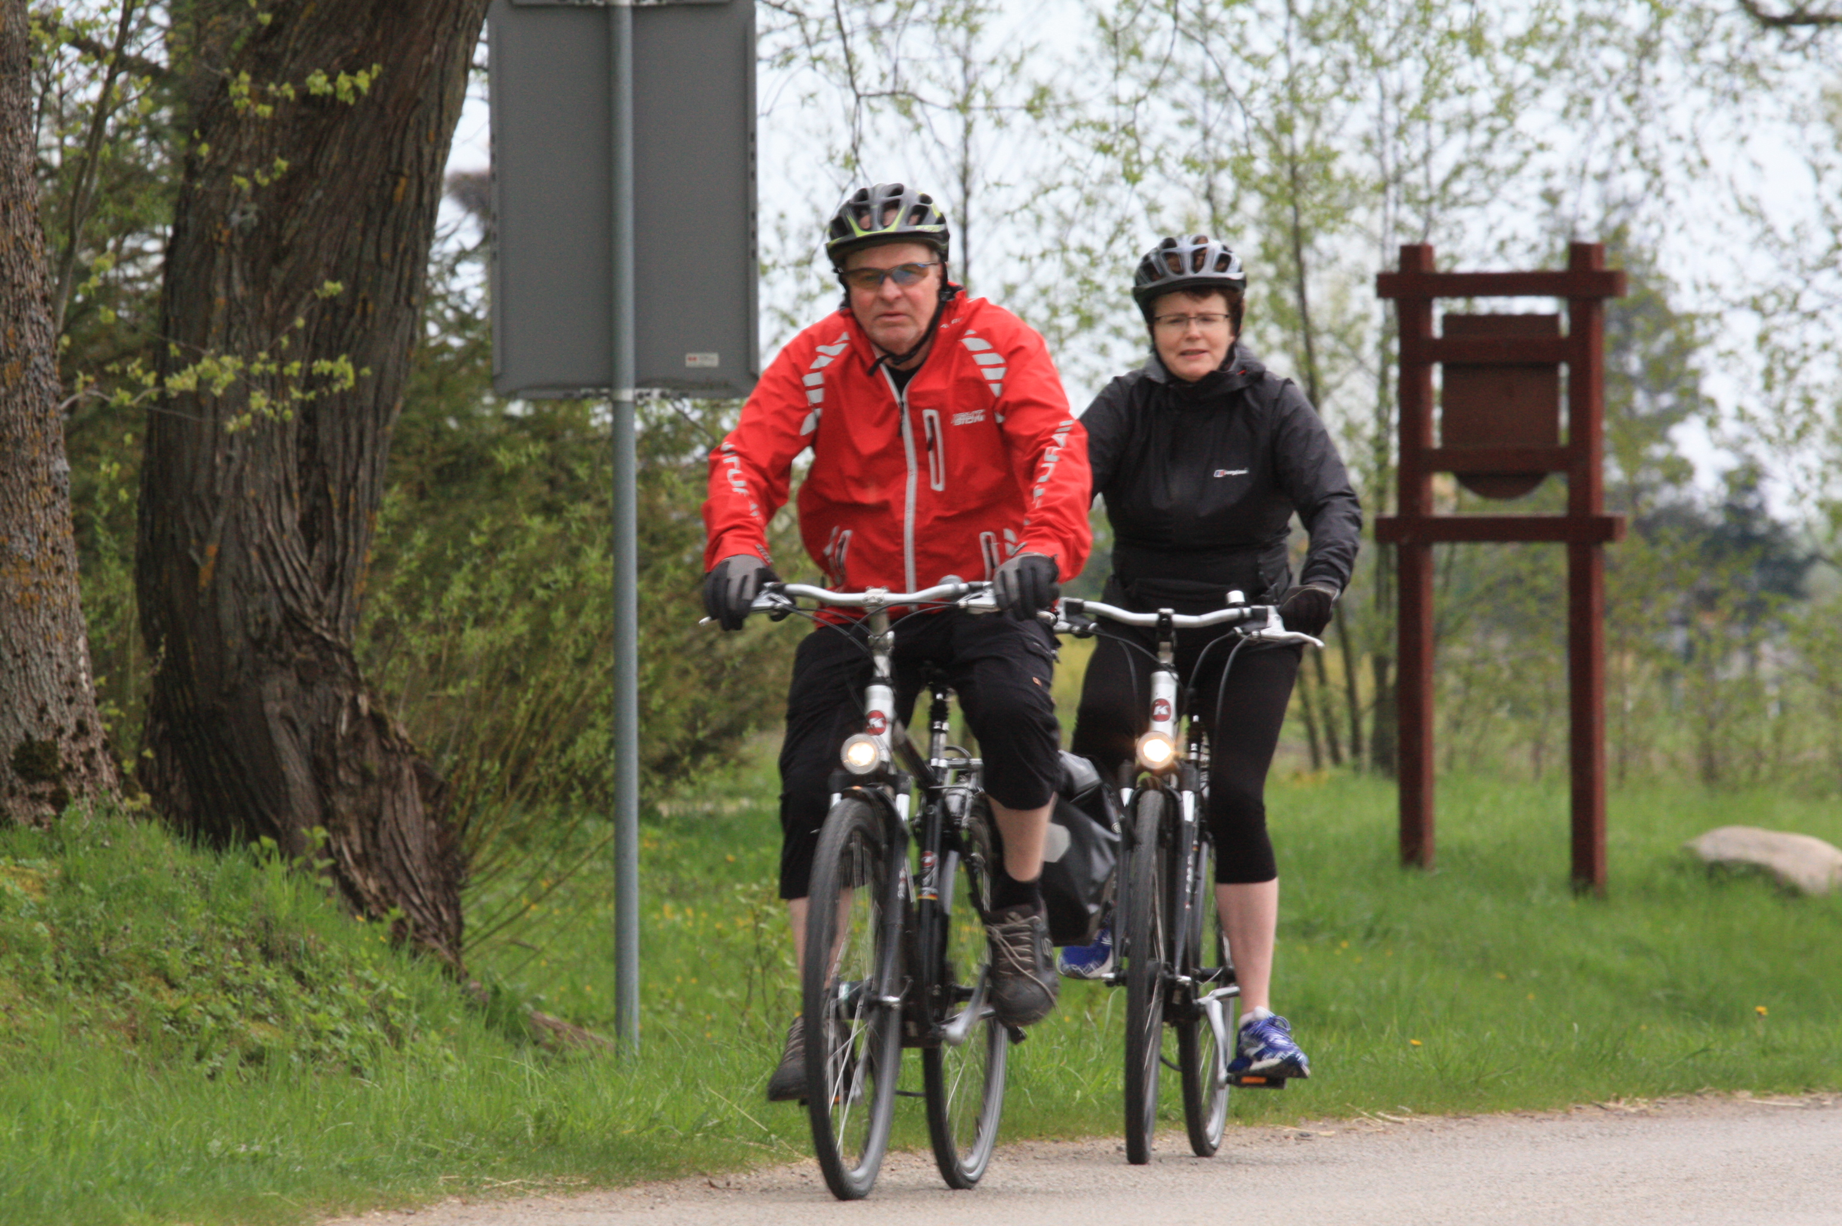

Contents

Introduction 3
Product criteria and explanation 4
Senior discount card 7
Product examples 8

Project “A bottom-up, stakeholder-driven product for individual senior off-season travel to rural micro- and SMEs,
established and managed through corporate agreements” (75/G/ENT/CIP/13/B/N03S01)

Project Partners:
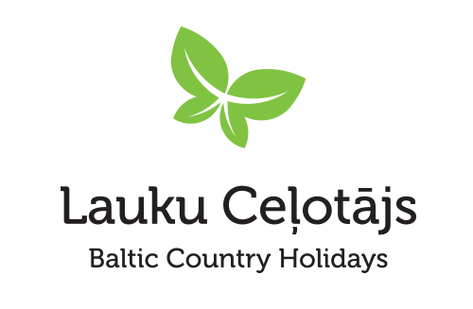 |  |  |  |  | 
Latvian Country  Tourism Association "Lauku ceļotājs"  www.countryholidays.lv | Norwegian Rural  tourism and local  food "HANEN"  www.hanen.no/ | Toerisme Vlaams-  Brabant (BE)  www.toerismevlaamsbrabant.be |  |  |  | European Federation  of Rural Tourism – EuroGites  www.eurogites.org
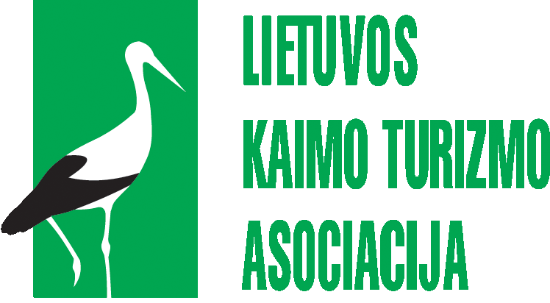 | 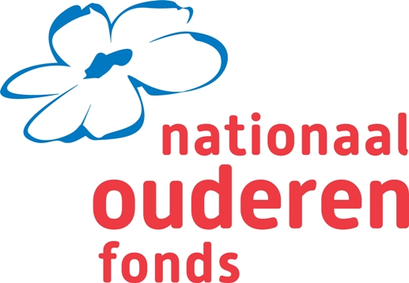
Lithuanian Countryside Tourism Association  of Lithuania  www.atostogoskaime.lt | NFE – Nationaal Ouderenfond (NL)  www.ouderenfonds.nl/

Introduction
This guideline has been developed under the project SenGor – Seniors go Rural, where the aim was to create a tourism product for individual senior off-season travel to rural micro - and SMEs. The present guideline is based upon the rural tourism off-season product criteria that were found by the project team through a feasibility study. The product is aimed at active seniors of age 55+. They are characterised as being aware of their older age and therefore willing to enjoy their life to the maximum. They spend their money on nice things that are meant for people of their age. Their motto is ´you only live once´ and they want to keep active and enjoy themselves. They are not adverse to using products for older people (hearing aids, glasses, walking aids, etc.) if that is necessary to keep on staying active. The criteria are described and explained further in the guideline to help rural tourism accommodation service providers to prepare for this target audience.

To promote and sell the product, the “Seniors go Rural” member card has been developed. The card is based upon agreement between a rural tourism service provider and a rural tourism marketing organisation distributing the cards to the organisations of seniors from where the cards are available to individual seniors. The operative model of the card is described in a separate chapter of the guideline.

Another chapter presents some examples of rural tourism off-season products for seniors. The examples are selected from Latvia, Lithuania, Norway and Belgium.

Product criteria and explanation
Object | Criteria | Guideline
- Information  and bookings | Precise description of  the accommodation and services (accessibility, etc.) | Description should precisely characterise the conditions in the accommodation from the point of view of accessibility and convenience, e.g., if the guest rooms are on the ground or upper floors, what are the stairs or other facilities to enter the building and rooms (e.g., a lift, a ramp, etc.).  Precise information should be provided about all services that are available with their prices and conditions.  Information should be provided in the languages in which hosts can communicate with guests.
 | Accessibility information marked with special pictograms | The pictograms not only show the conveniences but also tell about other guests that might be staying. If the facilities are convenient for, e.g., customers on whelchairs, it is likely, that guests will find themselves among similar group, with similar needs and expectations. It makes them feel much more comfortable than staying in a guest house favoured by, e.g., cycling groups or families with small children.    - Wheelchair accessible (accommodation that is fully accessible, no ledges, barriers, wheelchair toilets available, etc.).  - Walking aid accessible (accommodation that is fully accessible, no barriers, lifts instead of stairs, no wheelchair toilets but handgrips).  - Walking stick accessible (accommodation that has some barriers but no stairs, no special toilets but with handgrips).  - No special accessibility (stairs, no special toilets, no handgrips).  - Very fit (accommodation and activities for fit people with sports, cycling or walking).
 | Description of local activities and services. | The description should be provided in main customer languages, and should contain clear information about availability and accessibility, including booking information.
 | Contact information in the destination and local contacts for assistance and medical aid. | Information how to reach hosts in case of necessary assistance, and how to reach medical and other services in urgency. It is frequently a problem that local medical staff would not be able to communicate in foreign languages. Therefore the local contact information should be provided ensuring that the answering person is able to communicate with the guests and organise the necessary assistance.
- Price | Off-season discounts | Seniors would expect discounts, and they have to be clearly presented (off-season, senior club or any other).
- Assistance | Assistance with luggage handling | Seniors would expect assistance with luggage handling as part of service. It has to be provided that the luggage is carried for them e.g., from the car/bus to the room, etc.
 | Luggage transfer  (if necessary) | Safe luggage transfer can be offered as extra service or as part of service, if necessary (e.g., if seniors choose to travel by bicycle form one accommodation to the next, etc.).
 | Assistance to overcome language barrier | There has to be a language support available to solve unexpected situations and to handle everyday service. For easier communication, it is possible to use mobile translation applications, vocabularies, etc.
 | First aid available | First aid box at the facility, and first aid telephone numbers exposed in a visible place. If the accommodation is in a remote rural area, it might be useful to get in contact with the nearest medical station and provide GPS coordinates of the accommodation facility so that in case of emergency the brigade can find the place easily and on time.
- Location, rooms, surroundings | Easy to get to | It is important that the place is easily accessible – with good road, clear signposts, and GPS coordinates.
 | Safe destination | The destination should be safe, with friendly local community, no heavy traffic, etc.
 | Pleasant, beautiful,  well maintained surroundings | Attention should be give to the surroundings – the yard, the garden, etc. Everything should be well kept, aesthetic and in good technical condition to prevent accidents.
 | No construction barriers | No custruction barriers indoors and outdoors, like difficult steps, slippery trails, hight thresholds, long distances between parking and buildings, complicated locks at the gates, etc.
- Equipment | Shallow stairs and rooms no higher than one floor to ascend | The stairs should meet the building regulations. The steps should not be too high or too narrow. The steps should not be slippery or with worn rounded edges.
 | Banisters | Banisters should be conveniently placed, in full length of the stairs to give the necessary support.
 | Toilet and bathroom equipment and installations suitable for elderly people (handrails by the buth tub, WC seat, etc.) | Handrails should be installed in suitable places to ensure convenient and safe use of bathroom facilities. Slippery surfaces may represent danger, therefore attention shoudl be given to bath mats and anti-slip materials in the bath tub and on the floor. In some cases, instruction pictograms might be useful showing how to adjust water temperature or switch between shower and tap.
 | Bed mattrace in appropriate height for sitting. | The sitting should be neither too high, nor too low for sitting. Seniors would not enjoy using low beds, as it might be difficult to rise up. Attention should be paid to the quality of mattrace.
- Staff | Personal, friendly attitude. | In case of seniors, personal attention is of extremely high importance. They would expect friendly communication and understanding of their special needs and wishes. The staff should be skilled / experienced in interpersonal communication and solving conflicts. The staff should have the necessary patience to explain things clearly, make sure that the client has understood everything right, to cater for and anticipate a variety of small enquiries and requests.
 | English knowledge and ability to communicate with people speaking foreign languages. | English language would be a minimum of the required foreign language skills. The staff should be able to communicate in the native languages of the main customer groups of the establishment. Communication in client’s language adds to the feeling of comfort and safety, and can be a motivating factor in choosing the holiday site.
 | Local knowledge | Seniors are more than other groups interested in cultural and historical past and traditions of the places they visit. As part of communication with guests, local knowledge and good presentation skills is important for the staff.
- Food service | Good quality, freshly made food, local foods. | Apart from being fresh and good quality, the food has to be presented and served. Local foods have to be explained. If specific, they may be served in small portions for tasting. It is important to inform about the origins of the food, e.g., if the food is biologically or otherwise certified, grown/produced on site or in neighboring farms, etc. Dietary needs of guests should be carefully considered.
 | Food easy to consume | Attention should be given to texture of food. E.g., it should not be too hard to chew; fish should be prepared so that fish-bones are removed.

Senior discount card
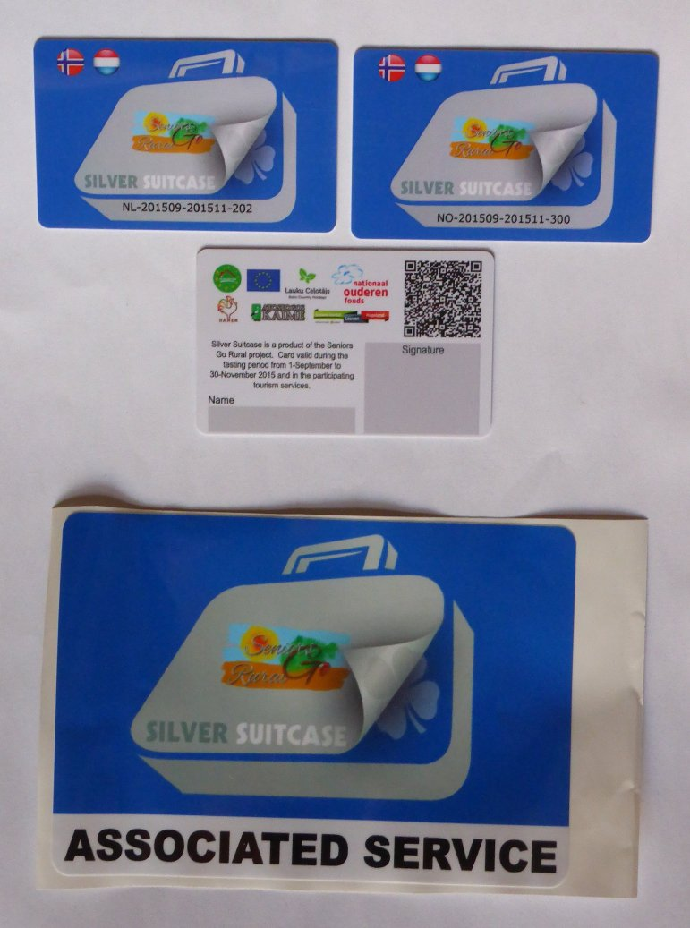
To make the SenGor products available for the market, a special senior discount card was created under the label “Silver Suitcase”. This card is part of a Europe-wide system under general rules.
Before a card is issued, a formal agreement must be established between an organisation representing senior clients (usually, a regional or national seniors association) that distributes the card, and a national or regional rural tourism / marketing organisation representing the service providers who will accept this card. This agreement includes rules about distribution and control of the “Silver Suitcase” card, its individual design elements as in the case of the “Seniors Go Rural” initiative, and others.

All such agreements are registered with the European rural tourism organisation EUROGITES that runs a web site promoting the senior friendly rural tourism products in its member countries which operate under the “Silver Suitcase” system.
Card distributors (Senior associations) promote the specialised rural tourism off-season product to their target audience and distribute the cards to individual seniors. The card holders are registered, this information is available to both parts for control purposes.

How does it work for rural tourism providers?

- The rural tourism/marketing organisation signs a contract with a rural tourism service owner willing to offer a rural tourism product under special conditions for seniors that hold the card. This contract includes all the relevant conditions and the operational procedures. Among others it defines:
- The period when the product and its conditions can be used by card holders
- The discount or special arrangement that a cardholder is entitled to receive
- The discount is valid for the card holder and one accompanying partner.
- The discount has to be shown on the invoice.
- The rural tourism service owner registers the Silver Suitcase customers for statistic purposes and reports upon request to the organisation that distributed the card.
- The accommodation owner guarantees good quality and professional service according to the Product Criteria set up above in <1>.
- Contingency procedures in case of conflicts
- The card is valid both for advance bookings and for on-site bookings. Bookings can only be rejected in case of no availability.
- The card holder makes bookings directly with the rural tourism services. He must indicate at the moment of booking that the Senior discount card will be used.
- Validity of the card and legitimate ownership must be checked upon arrival of the client. Cards must bear the name of the cardholder and his signature; otherwise they can be rejected.
- If in spite of compliance with <3> a valid cardholder does not receive the Silver Suitcase discount, the rural tourism service owner is liable to reimburse the excess charge at a later stage.
- Establishments offering the Silver Suitcase products expose stickers at the entrance, in the accommodation premises or other, as appropriate.
- The card distributor is responsible to explain all conditions and terms of use to the card holder. The national / regional rural tourism / marketing organisation undertake to involve in disputes that might arise between card holders and service providers during their stay.

Product examples
The following examples characterise the rural tourism product that is of interest to senior audience and suitable to their needs and interests. The examples show the description and services.

- The Birini Manor, Latvia
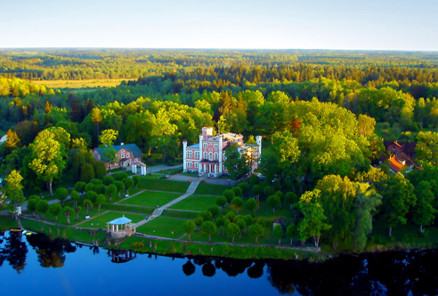
Surrounded by parks, Birini Manor rises on the hill near the lake. It was built in 1860 and retains it ancient charm. This romantic place is situated 1h drive from Riga and 15 minutes away from the Baltic Sea coast. At the estate there are large park territories for walks, horseback riding or bikes for hire available, boats at the lake. The manor has fine restaurant, sauna with pool. Transfer from Riga is available.


Accessibility: At the manor there are wide staircases. Senior guest are placed at the first or second floor or at the Gardener's house next to the manor building. Gardener’s house has only few steps. Park is easy to walk.

- Booking with member card number on:
- map: http://www.celotajs.lv/en/e/map/birinupils?43
- www.birinupils.lv, hotel@birinupils.lv
- Address: Bīriņi, Limbažu nov., Latvija

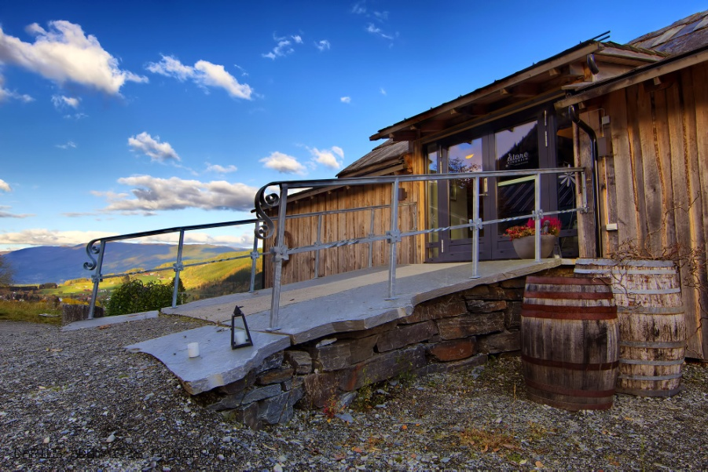
- Explore the Fjords – Store Ringheim, Norway
Welcome to Store Ringheim! This farm hotel is placed in Voss, about 1h 30m drive from Bergen.
The farm has been in the Ringheim family since 1778. Today’s hotel/guesthouse is placed in Gamlahuset (“the old house”), and contains six rooms with a total of 14 beds, all with private bathrooms w/shower. The restaurant area used to be the sheep fold at the farm, and serves local food.


- Nemunas tour Guest house, Lithuania
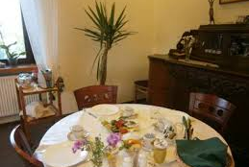
Family run cosy guest house only a 15-minute drive from the Old Town of Kaunas. It’s not important that it’s a little way out of the centre because it’s one of the best guesthouses in Lithuania. Find a large green house complete with several bright rooms and apartments, an army of communal facilities from washing machine to sauna and a charming husband and wife running it all.
If you want to eat during your stay (you can book your stay with or without breakfast), the emphasis is on the healthy, and if that isn’t enough they can also organise tours and activities nationwide.

Characteristics of the accommodation: level of accessibility and senior friendliness, stairs, lifts, etc.

Nemunas Tour Guesthouse is located in the quiet residential area of Ringaudai. It offers free Wi-Fi and free parking. Some rooms are located on the ground floor. The staircase with a hand rail leads to the second floor. Tea and coffee-making facilities can be found in every room.
The daily breakfast at the Nemunas Guesthouse includes many local products such as organic vegetables and fruits. Luggage assistance available all the time and owners Jurgis and Danute will do their best to make your stay hospitable. The daily breakfast at the Nemunas Guesthouse includes many local products such as organic vegetables and fruits.

- B&B Luttelkolen, Belgium

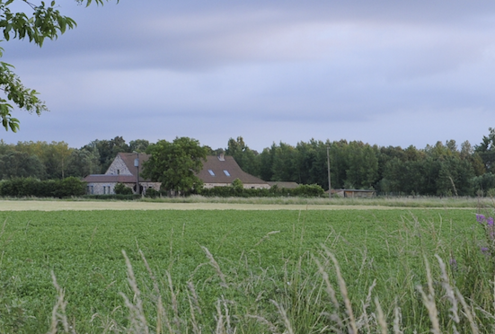
Looking for a lovely place to stay? Lieve & Luc welcome guests to their restored farmhouse in the heart of Hageland, a stunning region between Leuven, Diest, Tienen and Aarschot. The rural surroundings around Horst castle, just a stone’s throw from the B&B, give plenty of choice for a gentle stroll or energetic bike ride. As an experienced regional guide Lieve is well placed to give you some tips.

The communal area is used as a breakfast room and sitting room. It’s a lovely cosy room with a wood-burning stove. Besides the B&B there’s also a holiday home with room for four. So in total ten people can be accommodated.
Characteristics: all rooms are on the ground floor, are comfortably equipped with all mod cons and have direct access to the beautiful south-facing terrace. Box spring beds, which can be split into two if required, and dark curtains ensure that guests have a wonderful night’s sleep.

The modern bathrooms are complete with washbasin, WC, walk-in shower and ecological bath products. Selected linen is bio and fair-trade. Rooms are a pleasant place to relax thanks to a comfortable sofa, Wi-Fi, internet, TV, books and games. Coffee and tea are available in the rooms. The largest room is accessible by wheelchair and has a walk-in/roll-in shower, raised toilet, lowered basin and unhindered access to the room from the car park. Those wanting more independence can book the ‘Horstkamer’ with a small but well-equipped kitchen available. This studio is a home from home.

Project: Seniors Go Rural (75/G/ENT/CIP/13/B/N03S01) (2014 - 2015) Facilitating transnational low season tourism exchanges in Europe encouraging Senior Citizens to travel Project duration: 01.09.2014 - 29.02.2016. Project information: http://www.celotajs.lv/cont/prof/proj/SenGoR/Sengor_eng_active.html

