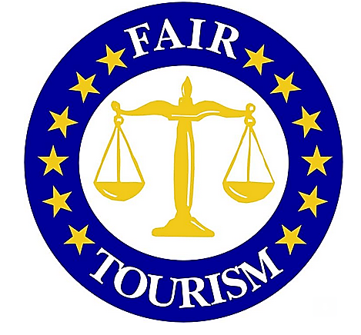
- Improving the learning content of CSR Training Course periodically, considering feedback from the participants.
- Identify further training needs as well as the most efficient and responsive training methods.
- Establishment of national and transnational networks dedicated to CSR in tourism SME’s.
- Development of an easy CSR management system that would be relevant to small and micro businesses in the tourism sector.

The Fair Tourism policy paper has been published, which summarises experiences and outcomes from the project activities and gives recommendations to European Vocational Education Training (VET) and Higher Education (HE) institutions, together with local, regional and national stakeholders. The policy paper recommends the following;
- Monitoring of CSR awareness and implementation by SME’s in the tourism sector.
- Reiterating the European Survey periodically in the respective countries to indicate the progress which should also by extended to other European countries.
- Launching of the Fair Tourism CSR Training Course to other VET and HE institutions across Europe.

For further details please contact the project co-ordinator:
Project Co-ordinator:
Institution: Grŵp Llandrillo Menai
Contact: Dr Shyam Patiar MBE
Tel: 0044 1492 542 316
Email: s.patiar@gllm.ac.uk

Fair Tourism Intellectual Output Three
This project is funded with support from the European Commission. This publication reflects the views only of the author, and the commission cannot be held responsible for any use which may be made of the information contained therein.

FAIR TOURISM

Guidelines and Training Programme for Corporate Social Responsibility in Tourism Developed by VET and HE Providers for Micro and Small Sized Enterprises

Grant Agreement No.: 2014-1-UK01-KA200-000057

  - Winter to Summer 2015 - 2016, Issue 3
INSIDE THIS ISSUE:
Fair Tourism Intellectual Output Three ⏐ Third Project Meeting - Germany ⏐
First International Conference - Germany⏐ Final Project Meeting - UK ⏐
Second International Conference - UK ⏐ Partnership

http://ssatc.eu/
First International Conference Germany
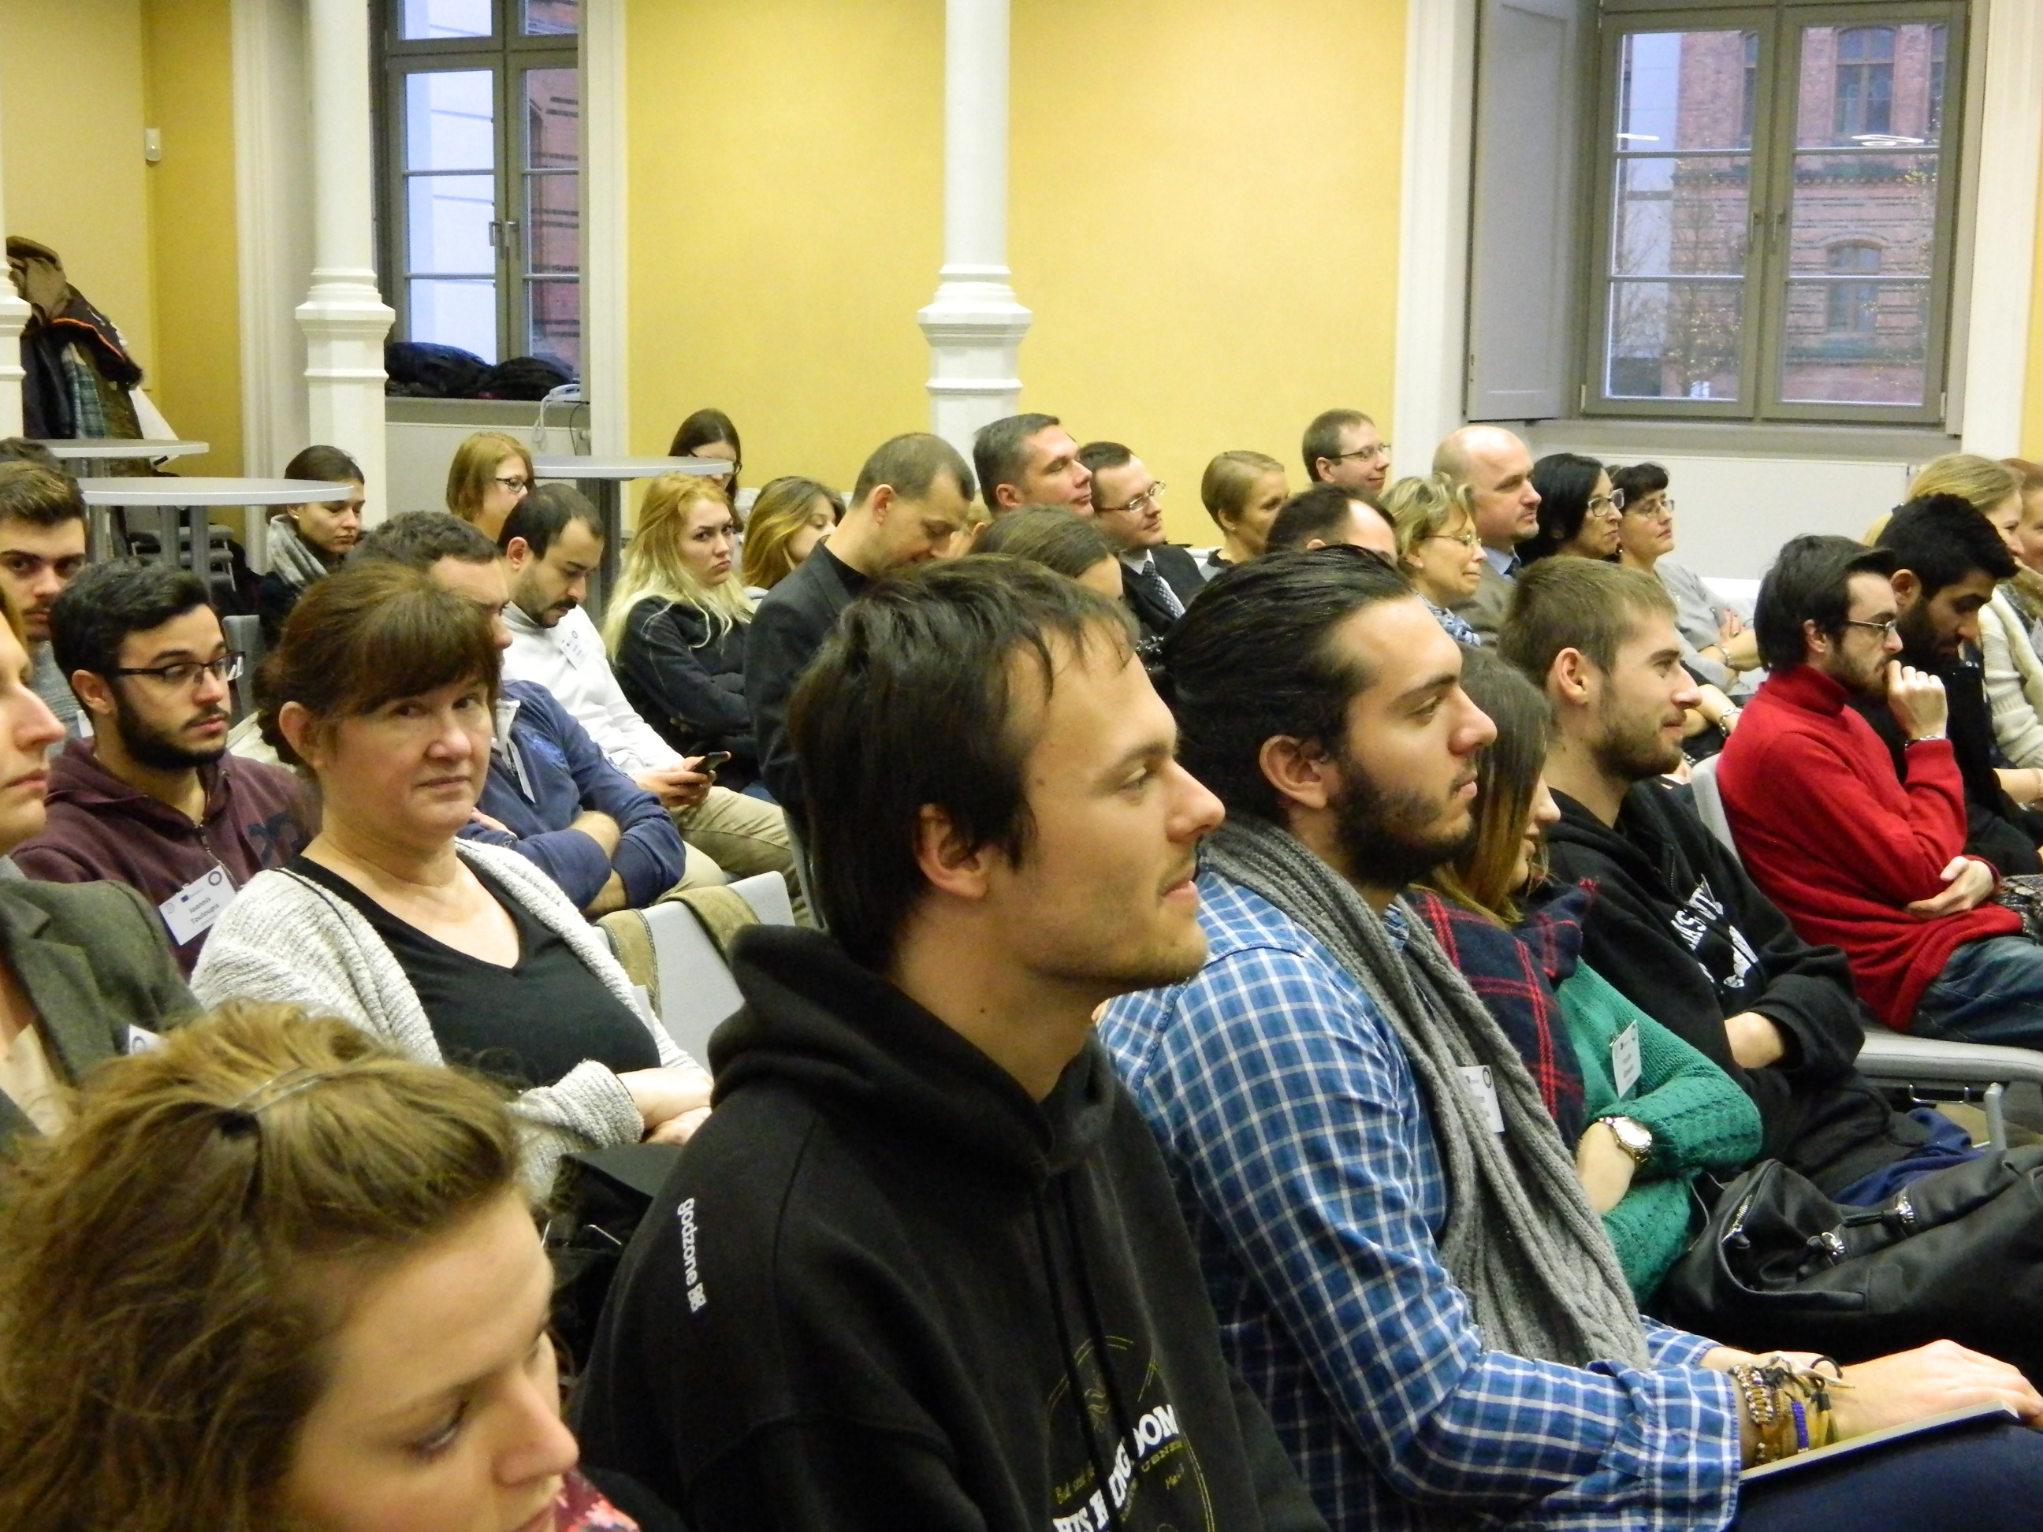
The Fair Tourism First International Conference was held at Ernst Moritz Arndt Universität Greifswald, Germany and took place on Friday, 11th December 2015. There were 91 delegates in attendance from across Europe. The delegates were given an overview of the Fair Tourism project.
Dagmar Schulz from The German Associatio0n for Small and Medium Sized Businesses presented a paper: SME between the Respectable Trader and Corporate Social Responsibility – a field report from Mecklenburg-Vorpommern.
The second presentation was on the importance of tourism in Poland and its growth in relation to central Europe, which was presented by Joanna Hernik of West Pomeranian University of Technology in Poland.
There were also presentations by the project partners on Intellectual Output One: Fair Tourism Research Report, Intellectual Output Two: CSR Training Course (to be piloted) and Intellectual Output Three: Fair Tourism Policy Paper initial proposal and how conclusions from the Research Report will feed in to the Policy Paper. The presentations concluded with two recommendations: 1. Financial support for the implementation of CSR in tourism SME’s, and 2. CSR Training Course to be integrated by the Higher Educational and Vocational Education Training institutions.

Third Project Meeting Germany
Third Transnational Project meeting was organised by Ernst Moritz Arndt Universität Greifswald, Germany and took place on Thursday, 10th December 2015. 11 delegates attended the meeting from all project partner countries. At this meeting the progress on the three main intellectual outputs were presented and the way forward was discussed:
Intellectual Output One: There has been an increase in the number of respondents to the European on-line research survey. A draft if the European Research Report was presented.
Intellectual Output Two: Each partner responsible for the production of module(s) presented their provisional curriculum and learning content. The CSR Training Course was approved for piloting.
Intellectual Output Three: Steven de Craen, from Belgium, presented an outline of the structure, layout and content of the Policy Paper. He advised about the contributions needed from each partner towards the content of Fair Tourism Policy paper. Such as best practices, challenges, needs, outcomes expected, action to be taken and organisations responsible for the implementation of same.

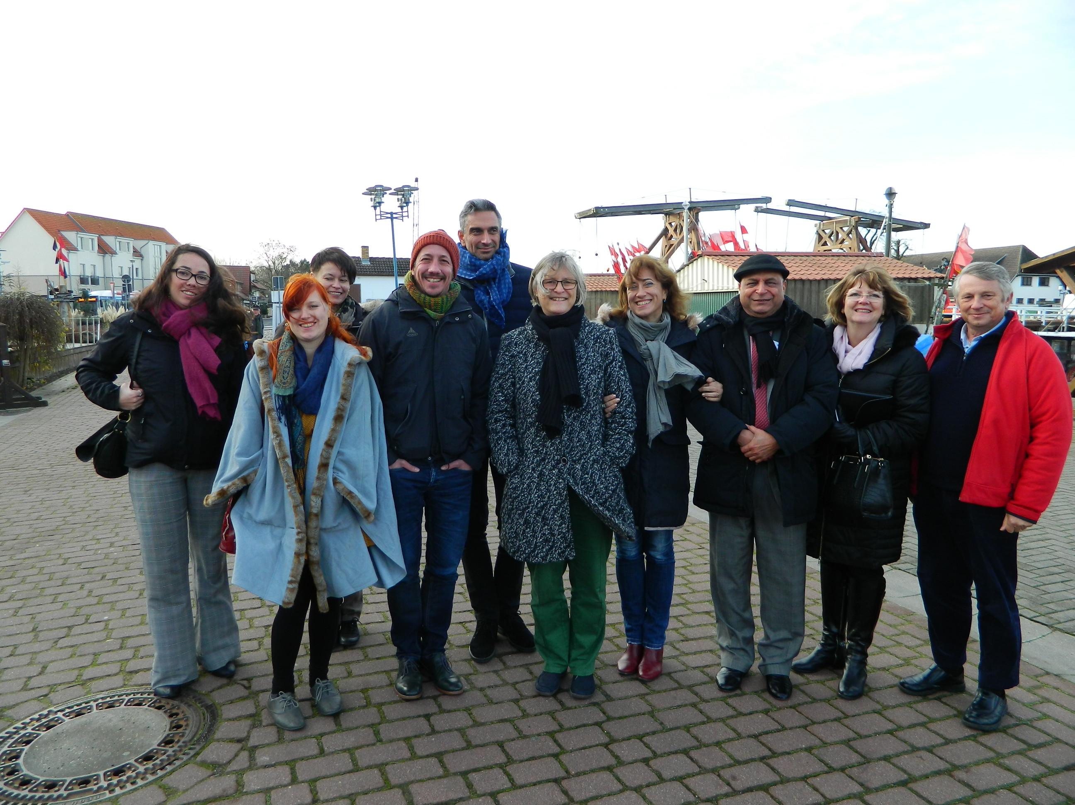

Fair Tourism

Second International Conference UK
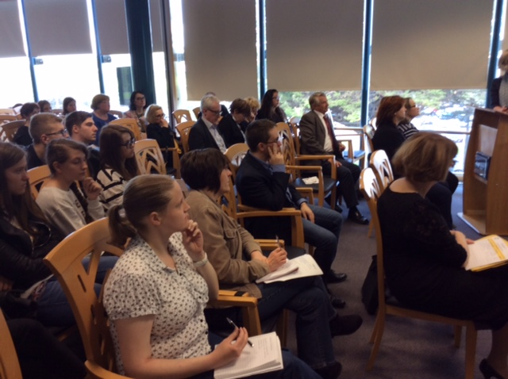
The Second Fair Tourism International Conference was held at Grŵp Llandrillo Menai, Rhos-on-Sea, UK on Friday, 20th May 2016. There were 139 delegates from across Europe in attendance. The delegates were given an overview and update on the Fair Tourism project by Wilhelm Steingrube.
Peter Cross, senior lecturer in hospitality management at the University of West London presented a paper: The Challenges of Implementing CSR in Food Service Value Chain by Tourism SME@s. He illustrated the challenges with specific practical examples from the sector.
Shyam Patiar from UK, presented a paper on the Importance of Human Resource Development in the Management of CSR by the Operators in Tourism Sector, specifically SME’s.
There were also presentations from the project partners on Intellectual Output One: the final Fair Tourism Research Report by Daniel Bulin (Romania), Intellectual Output Two: Ruth Bördlein (Germany) presented the final CSR Training Course Handbook including learning content and assessment strategy, and Intellectual Output Three: the final fair Tourism Policy paper including recommendations was presented by Steven de Craen (Belgium).

Final Project Meeting UK
The fourth and final Fair Tourism Project Meeting was organised at Grŵp Llandrillo Menai, Rhos-on-Sea, UK on Thursday, 19th May 2016.
There were 10 delegates in attendance at this meeting, with representatives from all project partner countries. The main presentation was on feedback of pilot course, being run by each partner. The final conclusions from this feedback were discussed and the agreement reached on the revised layout and structure of the training course.
The final version of the CSR Training Course Handbook for SME’s was presented by Ruth Bördlein from Germany.
Steve de Craen, from Belgium, presented the final draft of the Fair Tourism Policy Paper with conclusions and recommendations.
Shyam Patiar from UK, went through the Quality Assurance Strategy. Each partner also presented the dissemination activities carried out by themselves.
Finally, an educational visit was organised to the Bodnant Welsh Food Centre in Conwy to experience best practices related to sustainable food and rural tourism in Wales, UK.
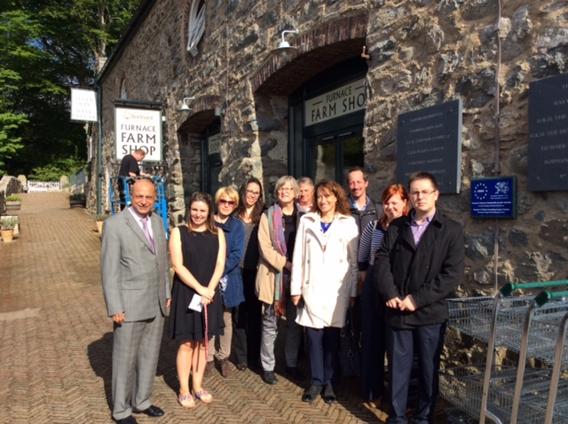

Fair Tourism

Fair Tourism

PARTNER INTRODUCTION
Grŵp Llandrillo Menai is the largest FE institution in Wales and has approximately 35,000 students a year, many of them in disciplines such as hospitality, catering and tourism. The college delivers a range of FE and University courses, all providing pathways to careers or HE level study.
Contact: Shyam Patiar Tel: 0044 1492 542 316 Email: s.patiar@gllm.ac.uk
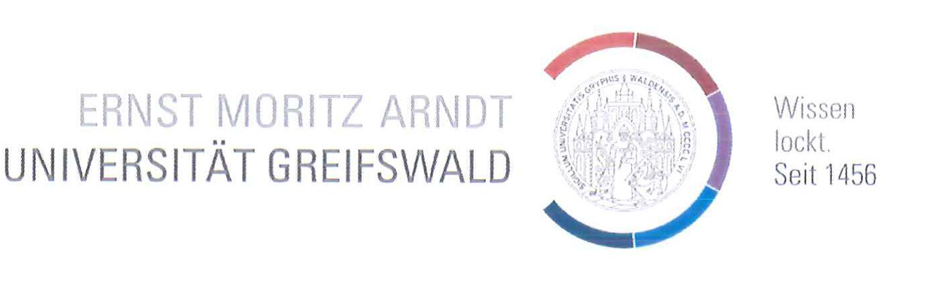 | Ernst-Moritz-Arndt-Universität Greifswald was founded in 1456 and is one of the oldest academic institutions in Europe. Over 12,000 students from all over the world receive modern academic instruction and exciting research opportunities in a time-honoured environment.  Contact: Wilhelm Steingrube Tel: 0049 3834 864 540 Email: steingru@uni-greifswald.de
WITHDRAWN | ENTER – European Network for Transfer and Exploitation of European Project Results is the largest dissemination network for EU project results and outcomes in Europe, boasting more than 760 member organisations from 35 different countries.  Contact: Petra Kampf Tel: 0043 316 329 005 Email: petra.kampf@enter-network.eu
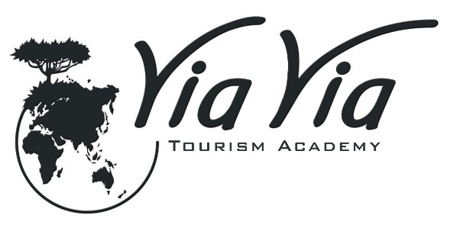 | ViaVia Tourism Academy is an autonomous non-profit centre of expertise and education in sustainable tourism development. Operating on four continents, the academy grew out of a socially responsible entrepreneurship approach, its aim is the deployment of sustainable tourism as a tool for development.  Contact: Dorien De Troy Tel: 0032 15 407 560Email: dorien@viaviatourismacademy.com
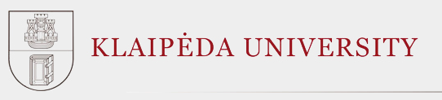 | Klaipeda University was established in 1991, its mission is to develop the University of Lithuania as a marine state and up-to-date centre of research, arts and studies in the Baltic Sea Region for the purpose of education and training of highly qualified specialists.  WITHDRAWN  Contact: Ilona Cesnaite Tel: 0037 0609 58 651 Email: i.cesnaite1989@gmail.com
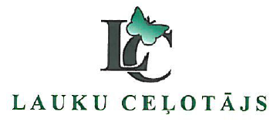 | Latvian Country Tourism Association was founded in 1993 and has been developing rural tourism products in Latvia ever since. The association is the oldest and strongest rural tourism organisation in Latvia, with staff experienced in the areas of environmental sciences, IT, public relations and biology.  Contact: Asnate Ziemele Tel: 00371 292 857 56 Email: asnate@celotajs.lv
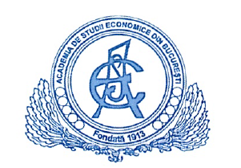 | Bucharest University of Economic Studies is a research intensive university which offers 22,000 students Bachelor, Master and Doctoral programmes of study across 11 faculties. The university promotes the reform of the education system applying the recommendations of the Bologna Process.  Contact: Gabriela Tigu Tel: 0040 213 192 023 Email: gabriela.tigu@ase.ro
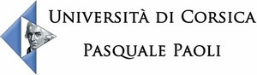 | University of Corsica Pasquale Paoli is a multidisciplinary institution. Founded in 1765, its campus hosts 4,300 students studying across four main areas; law-economic-management, literature-languages-arts, social sciences-humanities and sciences-health-technologies-sports.  Contact: Caroline Tafani Tel: 0033 646 411 008 Email: tafani@univ-corse.fr

