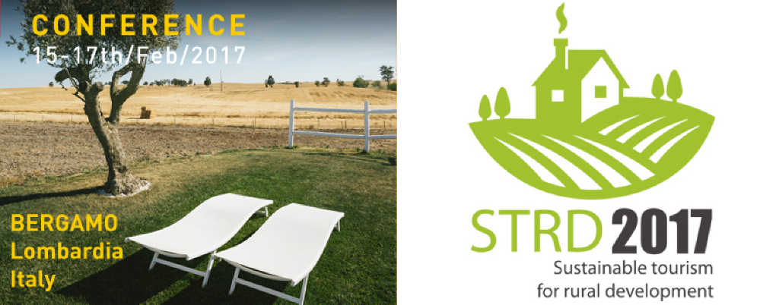

SUMMARY REPORT

The conference STRD2017 – Sustainable Tourism for Rural Development was celebrated as part of the “Salone Internazionale del Turismo Sostenibile e Accessibile”, in the context of the #IY2017 - International Year 2017 of Sustainable Tourism for Development and the implementation of the Cork 2.0 Declaration. It joined 102 participants – 67 from 24 different countries in Europe and 35 from Italy.

Regarding the Conference, discussions and deliberations took place around four main topics:
- Vitality of Rural Areas
- Value Chains around tourism in rural areas
- The Rural Experience as product to be offered to the client
- Digitalizisation

They were dealt with in an innovative format, based on four moderated panels where short statements and direct discussion amongst panellists substituted the usual monographic presentations. This concept was very successful, with the almost unique situation that at the closure session, the practical totality of registered participants was still in the room.
The different presentations and contributions that were made in the plenary part of the event can be found at the conference website: http://strd2017.org/papers/
Results of the WorkGroups on the four main topics, and a summary of the additional group on practical networking for common projects can be found in the Annex 1 a/b/c/d/e of this document.

Direct connection with reality and practical cases was provided through the parallel “Marketplace of Ideas”. This concept – designed as a contest of best ideas – generated a total of 38 contributions which are documented in a separate file.
The cases presented online were used to define part of the panels in the programme, contributing this way to a vivid combination of theory and practice.
Out of the 38 contributions, 13 international and XX Italian cases were personally presented by their representatives at specific panels in the foyer during the coffee breaks of the conference, generating multiple direct B2B and professional contacts during the event. A summary of these cases is attached as separate file, including contact data and their main characteristics.
This concept was a first-ever trial, and proved successful in spite of a very short time frame that had limitative effect on the number of candidates. It should definitively be repeated in future occasions, with adjustments regarding the rules of contest. The co-organiser EuroGites will keep the related online form open in the future, as a tool to generate a long-term repository of Best Practice cases.

Representatives of these ideas also participated at the B2B meetings on Friday/Saturday 17th/18th - February. While practical results can only be expected mid-term, the following results were already recorded:
- Protocol of cooperation with Montenegro and EARTH
- Project partner match for two applications at Erasmus+ KA2 call 2017
- Institutional contacts between the government of Bolivia and EuroGites
- Several other undocumented bilateral contacts and cooperation were generated – no exact information is available
- ADD STATS FROM THE EXPO MATCH MEETINGS

Promotion and dissemination of the event was very intense, but started very late due to the short time period that was available. A specific report on these activities has been prepared as separate file.
Regarding the efficiency of communication channels for participation,
- the different ways of direct contact through reliable peers (friends and colleagues, professional forums, or targeted mailing by the organisers) were clearly dominant.
- Untargeted electronic media such as the project website or Social Media were clearly less relevant for participation. However, they had a very good effect on the visibility of the event.
The impact of massive untargeted dissemination on participation is likely to be different in the case of a longer period of pre-promotion, where the exponential snowball effect is effective for building momentum.

An evaluation survey about the different aspects of the conference was conducted (see https://goo.gl/forms/txiw13ub8mM1WwuG3 ). Results are highly positive, with evaluation of 4,8 out of a score 1-6 for the overall satisfaction.
None of the evaluated aspects received a negative evaluation, however there is a list of details that could and should be improved.
The following conclusions can be summarized for future events:
Positive (to be extended) | Negative (to be improved)
Overall interactive concept of the event | More equilibrated quality of panellists
Opportunities for direct contact and networking | Opportunities for practical or business contacts
Structure and time control | Assure the panellists keep their time and stay in their topic
Bring together different points of view and visions that improve mutual understanding | More modular concept that allows to “pick” those sessions that are of interest
Methodology of work | Improve reports
Short, concise presentations with time for reflection and discussion | Control of panellists: keep time limit, and speak about the topic they are supposed to deal with
Mixture of theory and practice | Define more clearly what can be expected, especially for pure business stakeholders
Relaxed, participative ambience | Technical organisation and logistics
Social interaction and events

The detailed results of the survey can be found in Annex 2.

For future events, it is suggested to define a modular structure that combines several stand-alone sessions that are scheduled - at least in part - parallel to the B2C fair at the same premises.
However, different availability of stakeholders and speakers from public / administrative and private / business structures need to be kept in mind:
- Friday evening is absolute deadline for public or corporate participants, as well for speakers that come from this sphere
- A parallel event with the fair is ideal for business participants, as it allows them to reduce time and overnight cost.
A second edition could start on Thursday afternoon with more conceptual and theoretic content, and then get more “tangible” during Friday morning and afternoon. Specific B2B matchmaking or small monografic seminars could be scheduled for Saturday morning.

Conclusions of the conference were formulated and consensuated. They are attached as separate file.

Participants were generated through a highly effective cooperation and joint action between two European umbrella organisations
- EuroGites – European Federation of Rural Tourism www.eurogites.org that groups the sector of recreation in rural areas through 33 professional organisations related with rural tourism in 27 countries
- MER – European Movement for Rurality. Groups 17 European organisations related with rural development
  - Association internationale Ruralité-Environnement-Développement - RED
  - Fédération Européenne du Tourisme Rural - EUROGITES
  - Association européenne des Voies vertes – AEVV
  - Peri Urban Regions Platform Europe - PURPLE
  - Association internationale des Mouvements familiaux de Formation rurale – AIMFR
  - Association Européenne des Institutions d’Aménagement Rural- AEIAR
  - Fédération internationale de tourisme équestre - FITE
  - European association of mountain areas - EUROMONTANA
  - European Leader Association for Rural Development - ELARD
  - Centre Européen des Propriétaires Immobiliers - CEDIP
  - Comité Européen de Droit Rural - CEDR
  - Fédération Internationale pour l’Habitat, l’Urbanisme et l’Aménagement des Territoires - FIHUAT
  - Université Rurale Européenne – URE
  - Assemblée des Régions d’Europe – ARE
  - Association européenne des Sports de Nature - ENOS
  - Association européenne des Régions de Produits d’Origine – AREPO
  - Réseau européen des petites collectivités rurales pour la neutralité énergétique – RURENER
which, in turn, involved other structures at European level such as the
- COPA-Cogeca http://www.copa-cogeca.be : European umbrella structure of all farmer organisations in Europe
- ENRD – European Network of Rural Development https://enrd.ec.europa.eu/ : structure set up by the European Commission for guiding and supporting the implementation of the EU Rural Development policies and activities, mainly related to the CAP
- ELARD – European Leader Groups http://www.elard.eu/ : association of the Local Action Groups within the EU rural development policy
- EDEN Network http://youredenexperience.com/about-eden/what-is-eden/ . Gathers 140 sustainable tourism destinations across Europe

Considering the 67 international participants from outside Italy, the composition is as follows:
- EuroGites members 10
- MER member 5
- Local Action Groups 21
- Tourism organisations 10
- Entrepreneurs 8
- Academic and research 8
- Public sector 5 total 67

