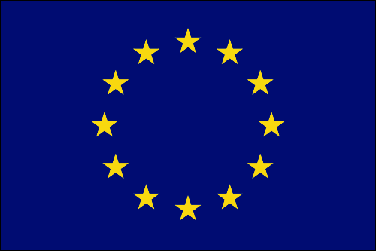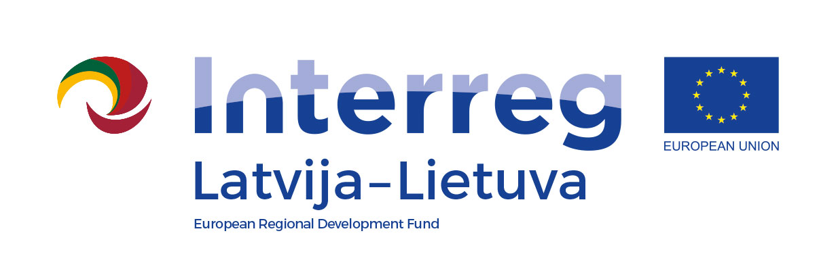
The project “Heritage based agritourism product development in Latvia – Lithuania” is co-financed by the EU Interreg Latvia – Lithuania programme 2014-2020.

Project “Heritage based agritourism product development in Latvia –Lithuania” (AGRI - HERITAGE)

Meeting 30th August 2017
Ilzenbergas manor, Lithuania
http://www.ilzenbergas.lt/en

AGENDA

10.00. Arrival Morning coffee.
10:30 Ilzenbergas manor visit
11:00 Project realised actions in first reporting period – short info by partners on achieved results:
- Activity C.7. Public events - “Open days in Latvia and Lithuania”
- Activity C.1. Communication guidelines, visual identity for actions.
- Activity T.1.1. Heritage agritourism criteria – downloadable pdf in EN, LT and LV languages. Product logo proposals.
- Activity C.9 Digital activities – press release, news in social media etc.
- Reporting: dates and documents.

13:00 Lunch

14:00 Planned project activities:
- Activity T.1.2. Heritage agritourism farm accreditation against product criteria.
- Activity T.1.3. and C.3. Heritage agritourism product database - specialized section in each partner site.
- Activity T.1.4. Product development and marketing handbooks. Handbook “How to open your heritage agritourism farm” (LC), “Guide to heritage agritourism product criteria” (LC), “Heritage agritourism marketing handbook” (LT). Presentation of content proposal by responsible partners.
- Activity T.1.5. Info-training seminars for heritage agritourism providers. Proposed time, content, advertisement.
- Activity T.1.6. Heritage agritourism tour itineraries in LV/LT.
- Publications – C.2. Map “Heritage agritourism farms”, C.4. Tour manual, C.5. Postcards.
- Activity C.8. Public events – participation in exhibitions
- Activity C.9 Digital activities – press release, news in social media etc.
- Next project meeting in LV – date.

Site visits on the way to Latvia.

